Create movie-style crawling credits in Microsoft Office PowerPoint
Learn how to add animations and creative movie-style crawling credits in Microsoft Office PowerPoint 2007.
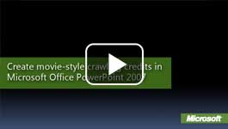

Video: Create movie-style crawling credits
Students can add movie-style end credits to their presentations by using the animation effects in Microsoft Office PowerPoint 2007. Watch the video

Examples
When applied to a list of text that is the same height as the slide, the Credits effect brings the text in from the lower edge of the slide and then scrolls the text up until all of the text exits the top of the slide. You can create a simple credit crawl or adjust effect options and add multiple text boxes to create elaborate scrolling lists. For example, a text box could scroll information about a famous author as a second box scrolls pictures of the author at a different speed adjacent to or behind the text.
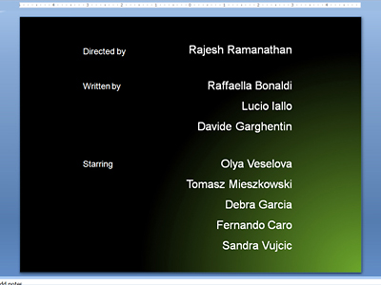
Create professional-looking credits at the end of your class presentation.
With the Credits effect, the length of the credit roll is limited to the height of the slide. If you want to create longer rolls or change the direction of the scrolling, you can use a Motion Path effect.

Type your credits in a text box
- Open your presentation in Office PowerPoint 2007, and add a new blank slide after the last slide.
- On the Insert tab, in the Text group, click Text Box, and draw a text box at the top of the slide.
- Type your credits in the text box.
If your credits are no longer than the height of the slide, you can use the Credits animation effect. If your text box runs below the lower edge of the slide or if you want to control the direction of the scroll, use a Motion Path effect.

Create a credit crawl using the Credits effect
- With the text box selected, on the Animations tab, in the Animations group, click Custom Animation.
- In the Custom Animation pane, click Add Effect, point to Entrance, and then click More Effects. Under Exciting, click Credits.
Tip: To change the length of time the credits are on the screen, experiment with the Speed setting.

Create a credit crawl using a Motion Path effect
- With the text box selected, on the Animations tab, in the Animations group, click Custom Animation.
- In the Custom Animation pane, click Add Effect, point to Motion Paths, and click Up. The Motion Path control line appears over the text box.
- With the control line selected, move the mouse over the green arrow until the cursor changes to a diagonal line. Then, drag the green arrow straight down to the bottom of the text box. Use the Zoom controls to show more of the workspace so that you can see below and above the slide.
- With the control line selected, move the mouse over the red arrow until the cursor changes to a diagonal line. Then, drag the arrow the same distance straight up, until it is roughly half the length of the text box above the top of the text box. 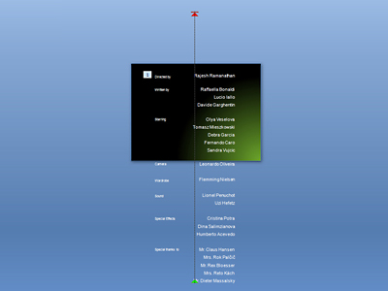
- Right-click the animation item in the Custom Animation pane, and click Effect Options.
- Clear the Smooth Start and Smooth End check boxes. On the Timing tab, in the Speed field, type the number of seconds that you want the credits to run. Click OK.
- Adjust the red or green arrows as needed so the credit crawl starts below the slide and scrolls off of the top completely. Adjust the Speed setting as needed to increase or decrease the speed of the crawl.
Tip: You can scroll the text box in any direction by changing the angle of the control line with the red or green arrows. For example, you can type your credit text in a wide horizontal text box and apply a horizontal Motion Path to create a ticker-type crawl.

