Create postcards in history with Microsoft Office Publisher 2007
Create a fun classroom project by teaching your students how to create postcards using Microsoft Office Publisher 2007.
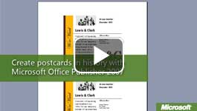

Video: Create postcards in history
Is there a better way for students to understand people who made history than to walk in their shoes? They can write and send postcards to and from famous historical figures to promote a speech or to announce a significant change to the government. Watch the video

Create postcards to and from historical figures
To help students get started, have them select a postcard template in Microsoft Office Publisher 2007. They can use one of the built-in templates or find a template on Microsoft Online. They can even start with a blank template or use one that you create for them. Office Publisher 2007 has all of the tools they need to lay out and design their postcards.

​Students learn about historical figures, such as Lewis & Clark, as they design fictitious postcards
- Decide on the scope of your project. Do you want to cover only certain historical figures or perhaps a specific time period? It is sometimes easier to give students a list of names from which to choose. For example, you could let them choose from a list of early American explorers.
- Have students decide which historical figure will write a postcard and which historical figure will receive one. For example, postcards could chronicle the Lewis & Clark expedition through correspondence between Meriwether Lewis and Thomas Jefferson.
- Students need to know some facts about the lives of each person. They could list important data, using Microsoft Office Word 2007, before they write their postcards. Possible facts about an historical figure might include:
  - The time period the person was alive.
  - Where he or she lived.
  - Why he or she is famous.
  - Key events of the person's life.
In Publisher 2007, students can include an image that is significant for the historical figure or meaningful to the contemporary world. For example, Lewis could send back drawings of the expedition.

Start a new postcard in Publisher 2007
- Open Publisher 2007, or in the File menu, click New.
If you want students to use a template that you created, they can open the template file the same way they would any other Publisher 2007 file. (For example, in the File menu, click Open.)
- In the left pane, under Publication Types, click Postcards.
- In the center pane, select the type you want or click View templates from Microsoft Office Online. If you want to create a postcard from scratch, select a Blank Size at the bottom of the list. Keep in mind that you can modify any aspect of the card design later.
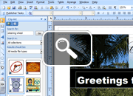
- In the right pane, view a larger thumbnail preview of the template.
- Under Customize, you can select a different color and font scheme. Also, under Business information, click Create new to enter information about the sender.
- Under Options, select a Page size (quarter page or half page), and select Side 2 information (address, speaker notes, and the like).
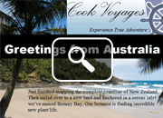
- Click Create, and Publisher 2007 creates your postcard.
- Click the placeholder text in the postcard, and type your own text. Then, add your own objects, such as pictures and shapes.
- The Format Publication pane is open by default. In this pane, you can modify the settings you entered when you set up the new postcard.
- When you are finished, save and print your postcard.

