Creating a Hyperlink to a Specific Page
Word allows you to easily create hyperlinks from one document to another. What if you want to create a hyperlink to a specific page in another document, however?
You can't specify a page number in a hyperlink; Word provides no way to do it. You can, however, create a hyperlink to a bookmark in another document. Follow these steps:
- Open both documents. For the purposes of this example, I'll assume that the document that will contain the hyperlink is document A and the document that is the target of the hyperlink is document B.
- Select document B.
- Position the insertion point at the beginning of the page you want to link to.
- Display the Insert tab of the ribbon.
- Click the Bookmark tool, in the Links group. Word displays the Bookmark dialog box. (See Figure 1.)
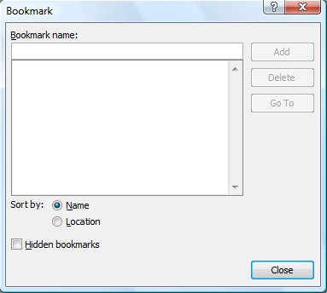
Figure 1. The Bookmark dialog box.
- Enter a name for the bookmark, such as "TargetPage" (without the quote marks).
- Click Add. You've now created the bookmark.
- Save document B.
- Select document A.
- Position the insert point where you want the hyperlink to appear.
- Press Ctrl+K. Word displays the Insert Hyperlink dialog box. (See Figure 2.)
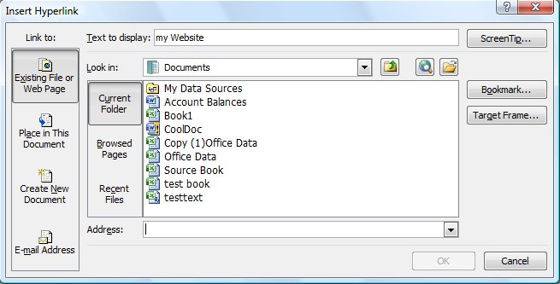
Figure 2. The Insert Hyperlink dialog box.
- In the Text to Display box, enter the text you want displayed for the hyperlink.
- In the Address box specify the full path and file name for document B. You can use the Browse for File button to help locate the document.
- Click the Bookmark button. Word displays the Select Place in Document dialog box. (See Figure 3.)
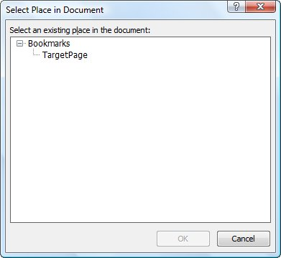
Figure 3. The Select Place in Document dialog box.
- Select the bookmark you defined in step 6.
- Click OK. Word closes the Select Place in Document dialog box.
- Click OK. Word closes the Insert Hyperlink dialog box and inserts the hyperlink in document A.
- Save document A.
That's it. If you click the hyperlink in document A, document B should be displayed on the page you want.
There is one thing to remember about this approach. How Word pages its documents depends on a lot of variables. For instance, if you insert the bookmark at the beginning of page seven of document B, and then you later do editing of the document that affects the paging, the bookmark will no longer be at the top of page seven. The upshot: If you change the paging in document B, make sure you move the bookmark to the correct position for the page you want to display.

