Creating Custom Underlines
When it comes time to underline some of the text in a document, many people rely on the Underline tool on the Home tab of the ribbon (in the Font group). This applies one type of underline, but Word has more than one type of underline you can use. You can see some of those underlining styles (eight of them) by clicking the down-arrow at the right of the Underline tool. If you want even more underlining styles, click the down-arrow and then click More Underlines. Word displays the Font tab of the Font dialog box. (See Figure 1.)
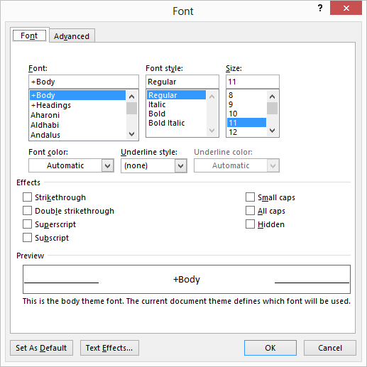
Figure 1. The Font tab of the Font dialog box.
Note that the dialog box includes a drop-down list entitled Underline Style. Click on the list and you can choose any of 18 ways to underline your text (including "None"). For some people, this variety still might not be enough. For instance, you may want to underline your text using fine dots, rather than a dashed underline or heavy dotted underline, both of which are options in the Underline Style drop-down list.
This is where it would be nice to create custom underlines in Word. Unfortunately, there is no way to do this. You could, of course, use the drawing capabilities of Word to create just the type of lines you want, but you would need to place them individually and then move them if your text moves.
A better solution, particularly if you will be doing lots and lots of underlining in a particular manner, is to create your own font that incorporates just the type of underlining you need. Using a font editor (there are many on the market) you can pick whatever font you want, modify that font to include the underlines, and then save the font under a new name. When you want the custom underline, just switch the font on the selected text.
Of course, if you create a custom font and then share the document with others, you will either need to make sure that the others also have the font or you'll need to embed the font within the document (as described in other issues of WordTips).

