Cross-Referencing Index Entries
Creating index entries in a Word document is easy, as you learn in other WordTips. It is not uncommon to cross-reference items in an index, and such cross-references require a change in how you create the index entries. For instance, instead of page numbers after an entry, you might have the text See Johnson, Abigail. To insert a cross-reference in an index entry, follow these steps:
- Select the text you wish to appear as the main index entry. This is the text under which the cross reference will appear.
- Press Alt+Shift+X. Word displays the Mark Index Entry dialog box. Notice that the Main Entry text box is already filled in with the text you specified in step 1. (See Figure 1.)
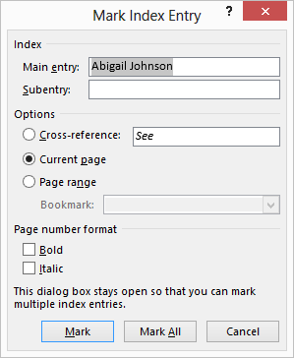
Figure 1. The Mark Index Entry dialog box.
- Select the Cross-reference radio button.
- In the text box to the right of the Cross-reference radio button, enter the cross reference, as you want it to appear.
- Click on Mark.
- Click on Close to dismiss the Mark Index Entry dialog box.

