Deleting All Footnotes
Certain types of documents require the use of footnotes to help document sources or provide additional information relative to the content being discussed. At some point you may want to delete all the footnotes in your document. One thing you can try is to do a simple search and replace to remove all the footnotes. Follow these steps:
- Press Ctrl+H to display the Replace tab of the Find and Replace dialog box. (See Figure 1.)
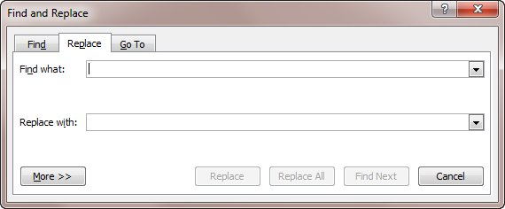
Figure 1. The Replace tab of the Find and Replace dialog box.
- In the Find What box, enter ^f. This indicates that you want to search for footnote marks.
- Make sure the Replace With box is empty.
- Click on Replace All.
- Close the Find and Replace dialog box.
This approach works because when you delete footnote marks, the footnote associated with that mark is also automatically deleted.
If you find yourself ridding lots of documents of their footnotes, you may want to create a macro that will do the job for you. This macro can then be assigned to the Quick Access Toolbar or to a shortcut key. The following macro will remove all the footnotes in a document:
Sub DelFoots()
Dim fn As Footnote

For Each fn In ActiveDocument.Footnotes
fn.Delete
Next
End Sub

