Deleting All Tab Stops
Joan is looking for the quickest way to delete all of the tab stops in a Word document. She wonders, specifically, if there is a keyboard shortcut that will do it.
There is no keyboard shortcut to remove tab stops—you must use the Tabs dialog box to accomplish the task. While you can use the keyboard to call up the Tabs dialog box and make selections within it, doing so doesn't technically count as a "keyboard shortcut." Here is the quickest way to delete all tab stops:
- Press Ctrl+A. This action selects the entire current document.
- Display the Home tab of the ribbon.
- Click the small icon at the bottom-right of the Paragraph group. Word displays the Paragraph dialog box.
- Click the Tabs button at the bottom-left of the dialog box. Word displays the Tabs dialog box. (See Figure 1.)
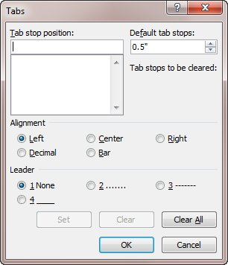
Figure 1. The Tabs dialog box.
- Click the Clear All button.
- Click OK.
Some have suggested that a quick way to delete tab stops is to simply select all the text (Ctrl+A) and then press Ctrl+Q. What this does is to remove all explicit paragraph formatting from the text. While it is true that the tab stops are a paragraph format, Ctrl+Q just removes any explicitly added tab stops; it sets the paragraphs back to whatever formatting is defined for each paragraph's style. So if the underlying paragraph style has tab stops defined, then those tab stops remain after Ctrl+Q is pressed—not all tab stops are removed.
If you need to remove the tab stops from a large number of documents, then you may want to use a macro to do the job. The following single-line macro removes all the tab stops from all paragraphs in the current document:
Sub TabsGone()
ActiveDocument.Paragraphs.TabStops.ClearAll
End Sub
You should understand two things about this discussion. First, deleting all tab stops doesn't get rid of any of the tab characters in the document. The best way to get rid of those is to use Word's Find and Replace capabilities.
Second, when you get rid of tab stops, Word's default tab stops automatically come into play. By design, the default tab stops are every half-inch, although you can change the default tab stop settings as described in other issues of WordTips. What you cannot do, however, is get rid of the default tab stops; there is no way to do this.

