Deleting an AutoText Building Block
AutoText has long been a powerful tool in Word. There are several reasons why you would want to remove an AutoText entry you previously created. The biggest reason is that you just don't need the entry any more. For instance, you may have defined a group of AutoText entries for a particular job you were doing. When the job is over, it is best to remove the AutoText entries.
You can remove AutoText entries by using the Building Block Organizer. (AutoText entries are considered one of several "building blocks" that can be created in Word.) To remove AutoText entries, follow these steps:
- Display the Insert tab of the ribbon.
- Click the Quick Parts tool in the Text group. Word displays a list of options you can choose.
- Choose Building Blocks Organizer. Word displays the Building Blocks Organizer. (See Figure 1.) (Building Blocks were introduced as a sort of "super AutoText" in Word 2007.)
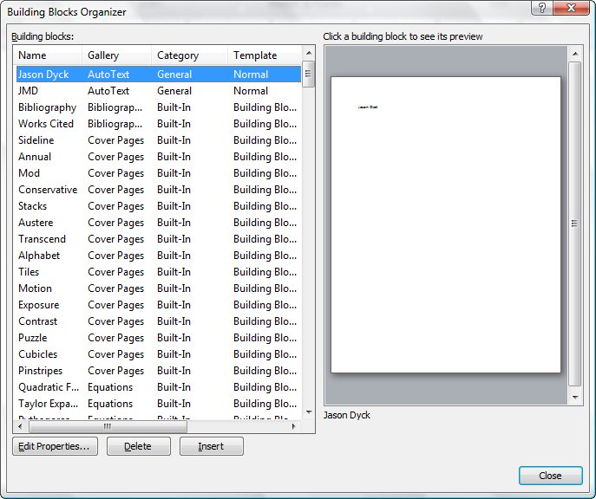
Figure 1. The Building Blocks Organizer.
- Select the name of your AutoText entry from the name list. (You can be sure it is an AutoText entry because the word AutoText shows up in the Gallery column of the Building Blocks Organizer.) You can use the preview area to make sure you selected the right AutoText name.
- Click on the Delete button and your entry vanishes after you confirm you want to delete it.
- Click on OK to close the Building Blocks Organizer.

