Develop an interactive story with Microsoft Office PowerPoint 2007
Learn how to create interactive storytelling presentations with Microsoft Office PowerPoint 2007.

Develop an interactive story
Students can work together or by themselves to design an interactive story using hyperlinks in Microsoft Office PowerPoint 2007. When readers run the slide show, they decide how the story progresses by clicking buttons that link them to different slides. Watch the video

Get started
Before opening Office PowerPoint 2007, students can create paper storyboards to design the flow of their stories. A storyboard consists of sketches of all the scenes in a story, including all the scenes that readers might possibly jump to while viewing the slide show. It also includes the plan for how to link the slides.
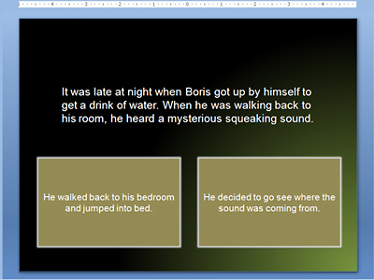
Readers choose from two different paths in this interactive story.
Frequently, an interactive story is made up of slides which consist of a short introductory paragraph plus two possible paths written on hyperlinked buttons. However, there are many possible ways to design interactive stories in PowerPoint 2007.

Create a storyboard
Before opening Office PowerPoint 2007, plan your interactive story on paper. A storyboard (that is, sketches of each page or slide) will help you keep track of the many possible scenes in your story. When you create your story in PowerPoint 2007, each scene will become a slide. If you want to be able to move scenes around as you design your story, try writing each scene on an index card. You can lay out the index cards on a large cork board. Then, use yarn to show how the scenes will link together.

Add your content to the slide show
- Start PowerPoint 2007 with a blank presentation.
- On the first slide, type the title and subtitle of your story. You can also include the names of authors.
- On the Home page, in the Slides group, click New Slide to add the first page of your story. Click the New Slide arrow if you want to choose a layout other than the default layout, “Title and Content.”
- Modify the layout to work with your content. For example, in this article, each slide will contain an introductory paragraph and two large Action buttons, so the layout must contain one text box and room at the bottom of each slide for the buttons.
Tip: If all of your slides will use the same basic layout, modify one of them and then right-click the slide and click Duplicate Slide to add a new one. Alternatively, you can create a custom layout in the Slide Master view.
- Referring to your storyboard, type the content for the first slide. Make a note of the slide number that corresponds to each storyboard scene. You will need that information later when you add interactivity.
- On the Insert tab, in the Illustrations group, click Shapes, and under Action Buttons, select the blank button. In the Action Settings dialog box, click OK to accept the default choice. You'll add the correct hyperlinks after you have included all of your slides.
- Draw a large button in the lower-left section of the slide.
- With the Action button selected, press CTRL+C and then CTRL+V to create a copy. Move the button to the right side of the slide, and resize the buttons so they are aligned at the bottom of the slide.
- Select the left button, and type the text for the first interactive choice. Select the text, and on the Home tab, increase the size of the font to match that of the introductory paragraph.
- Select the right button, and type the text for the second interactive choice. Then, format the text the same way. 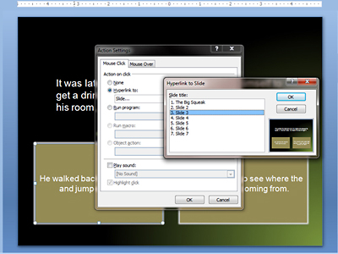
- Continue inserting slides and typing content until all of the storyboard scenes have been added. Keep in mind that the order of the slides in the Slide pane is unimportant because the slide show will progress according to the reader's selection.

Add interactivity to the slide show
- On the first slide, right-click the border of the left Action button (the first interactive choice), and click Edit Hyperlink.
- Click Hyperlink to, click the list box, and then click Slide.
- Select the slide that you want readers to link to when they click the button, and click OK twice.
- Repeat the steps to add a hyperlink to the right Action button and then to the buttons on all of the slides.
- To test a link, right-click the button, and then click Open Hyperlink.

Teacher Tips
- Have students develop their own interactive short stories.
Encourage them to imagine wildly different plot turns and character behaviors. Choose several short stories to feature in class and encourage class participation in choosing the path each story will take.
- Make your presentations more interactive
Create an interactive table of contents of your presentation by creating buttons and inserting hyperlinks to specific pages.

