Display fractions in a Microsoft Office Excel 2007 spreadsheet
Learn how to use Microsoft Excel to display fractions in a spreadsheet.
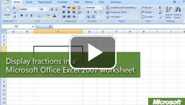

Video: Display fractions
You can format Excel cells to display decimals as fractions. Office Excel 2007 also performs mathematical operations on fractions and reduces and rounds fractions automatically. Watch the video

Change decimals to fractions
After you enter numbers and formulas, you can add formatting or text to make it easier for your students to read. For example, the following figure shows how Office Excel 2007 can be set up to display and calculate fractions.

To display fractions in an Office Excel 2007 worksheet
- On your worksheet, format the cells in which you want to display fractions (before entering any data). Select the cells.
- On the Home tab, in the Number group, click the Number Format drop-down list, and then click Fraction.
- Type numbers or formulas in the cells, and Excel displays the numbers or results as fractions. For example:
  - To display 5/8, type 5, followed by /, and then 8.
  - To display 38 5/8, type 38, followed by a space, and then the fraction.
  - To reduce a fraction or to convert a decimal number to a fraction, type the number and press Enter. Excel converts the number automatically and displays the result. For example, 8/24 becomes 1/3, 37/8 becomes 4 5/8, and 3.1416 becomes 3 1/7.
  - To perform mathematical operations on one or more fractions, format all of the cells you want to use as Fraction. In separate cells, type the fractions, and then type a formula that uses cell references. For example, in the figure below, the formula in the green cell multiplies the fractions in cells C9 and C10 and then displays the result as a fraction.
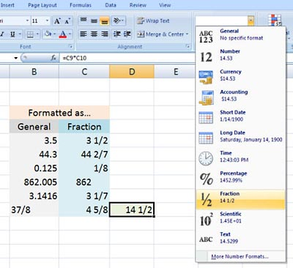
To modify the way that Office Excel 2007 displays and converts a fraction, click the Number Format drop-down list, and then click More Number Formats.

