Finding and Changing Word's Internal Commands
When you are developing macros, you may want to replace one of the built-in commands used by Word with your own macro code. In order to do this, you must find out the name used by Word to refer to the built-in commands. You can do so by following these steps:
- Display the Developer tab of the ribbon.
- Click the Macros tool, in the Code group. Word displays the Macros dialog box.
- Using the Macros In drop-down list, select Word Commands. (See Figure 1.)
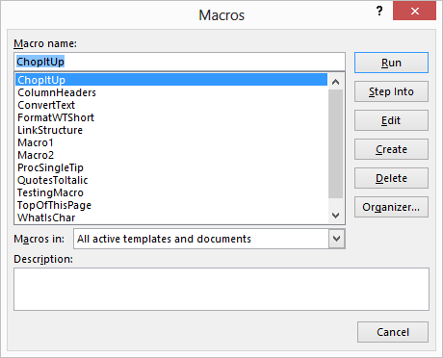
Figure 1. The Macros dialog box.
- Using the command list, locate and select the command you want to edit. Once selected, the name should appear not only in the list of commands, but also in the Macro Name box at the top of the dialog box.
Now, if you want to change the command, continue on with the rest of these steps:
- Using the Macros In drop-down list, select where you want your edited command saved. The command name should still appear in the Macro Name box at the top of the dialog box.
- Click on Create. Word starts the VBA Editor and shows the program instructions that make up the built-in command.
- Make your changes to the command.
- Close the Editor window by clicking on the Close icon in the upper-right corner of the window.
- Save your changes, if prompted.

