Fixing Word
Word includes an esoteric command that allows the program to "fix" itself. This means that you can instruct the program to examine all its components and reload them from the original installation CD-ROMs. In order to start this process in Word, follow these steps:
- Press Alt+F8. Word displays the Macros dialog box.
- Using the Macros In drop-down list, choose Word Commands. (See Figure 1.)
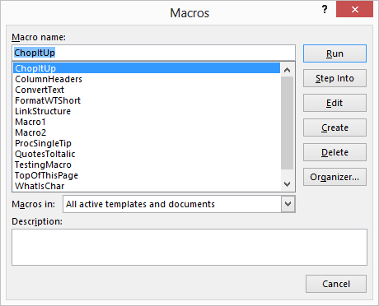
Figure 1. The Macros dialog box.
- In the list of Word commands, select the FixMe option.
- Click on Run.
This starts the process. You may be prompted by the program to shut certain documents or programs in order for the fixing to finish. Follow the instructions, as prompted.

