Getting Rid of the Ctrl+Click Message
Other issues of WordTips have explained how to use the ScreenTips feature in Word to create pop-up screen help in a document. When you move the mouse pointer over a hyperlink, you end up with a message that says "Use Ctrl+Click to Follow Link", which can detract from the use to which you want to put your ScreenTips.
So how do you get rid of the message? It's really quite easy:
- Display the Word Options dialog box. (In Word 2007 click the Office button and then click Word Options. In Word 2010 display the File tab of the ribbon and then click Options.)
- At the left side of the dialog box, click Advanced. (See Figure 1.)
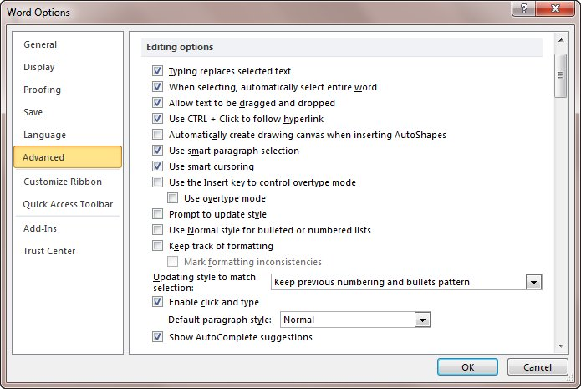
Figure 1. The Advanced options of the Word Options dialog box.
- In the Editing section of the dialog box, clear the Use Ctrl+Click to Follow Hyperlink check box.
- Click on OK.
There is a drawback to clearing this option in Word: Not only is the Ctrl+Click message removed, but so is the need to Ctrl+Click. All it takes is a single click on the hyperlink to do the jump.

