Handling Long Lines in Address Labels
Word allows you to easily create address labels from data stored in an external source, such as an Access database or an Excel workbook. Word essentially takes the information from those sources and "pours" it into the format you designate within Word. As the information is placed into the Word format, it is possible for one or more lines to be too long to fit within the allotted space in the label.
When an address line wraps to more than a single printed line, Word treats it like any other paragraph and left-aligns each line within the paragraph. What if you want the wrapped lines to not be left-aligned, but to have some other alignment? This is not as easy to do in Word, but can be handled in a number of different ways.
The first way you can handle the wrapped lines is manually. Obviously, if you create a new document when you merge your labels, you can look through the addresses, find those lines that are too long, press Enter where you want the line to break, and adjust the alignment on the second (run-over) address line. This, of course, is rather tedious. This approach does have its advantages, however. The primary advantage is that the run-over address lines can be formatted in any manner desired, i.e., indented, centered, flush right, etc.
If you are looking for a more automatic approach, the only thing you can do is to adjust the formatting of the paragraphs used for the lines in a label. If you anticipate quite a few long address lines, this is definitely the way to go. The normal approach is create your mail-merge document (for labels, of course), and then to adjust all the paragraphs in the labels so they use hanging indents. (This means that the first line will be left-justified, and additional lines will be indented to whatever degree you desire.) This approach doesn't give the benefit of being able to right-justify or center run-over lines, but the trade-off is that you don't need to manually adjust any lines. Follow these steps:
- Display the Mailings tab of the ribbon.
- Click the Start Mail Merge tool and then choose Step by Step Mail Merge Wizard. Word displays the Mail Merge task pane at the right of the program window.
- Using the steps in the task pane, indicate that you want to create labels and you want then in a new document.
- When prompted, specify a data source for your merge.
- Using the fields available to you, design how you want your mailing labels to look.
- Close the Mail Merge task pane.
At this point you have a sheet of labels on your screen and you are ready to format them to handle long lines properly. Follow these steps:
- Select the entire document by pressing Ctrl+A.
- Hold down the Shift key as you press the Left Arrow. This "unselects" the final paragraph marker in the document. (You should have everything in the document selected except the final paragraph marker.)
- Display the Home tab of the ribbon.
- Click the small icon at the bottom-right of the Paragraph group. Word displays the Paragraph dialog box. (See Figure 1.)
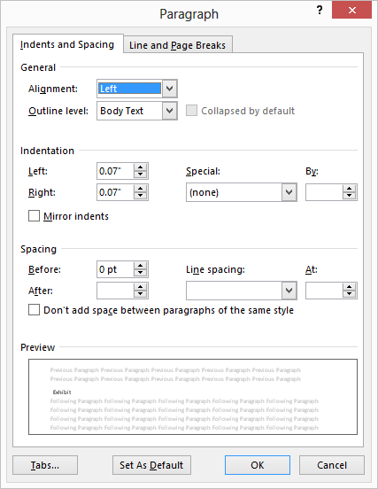
Figure 1. The Paragraph dialog box.
- Using the Special drop-down list, choose Hanging.
- Using the By field, specify how far you want the run-over lines indented. (The default is one-half inch.)
- Click on OK.
Your labels are now set, and you can do your mail merge as you normally would. The result is run-over lines that are indented from the left margin, which makes them stand out a bit.

