Hyperlinking to a Specific Excel Worksheet
Word allows you to easily add links to other Microsoft Word documents, such as those created by Excel. These links can be created in a number of ways, such as by using the Paste Special dialog box and choosing the Paste As Link option.
Excel also allows you to create hyperlinks to other Office documents. In many ways these hyperlinks are similar to regular links, but they have the express purpose of opening the target document and displaying exactly the information you want. For example, to create a hyperlink to an Excel worksheet, you would follow these steps:
- In your Word document, position the insertion point at the location where you want the hyperlink to appear.
- Click the Hyperlink tool on the Insert tab of the ribbon or press Ctrl+K. Word displays the Insert Hyperlink dialog box.
- Make sure Existing File or Web Page is selected. (See Figure 1.)
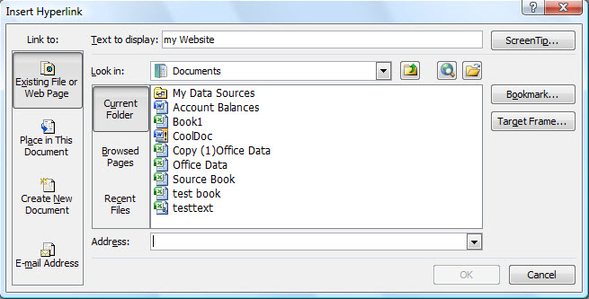
Figure 1. The Insert Hyperlink dialog box.
- Use the tools in the middle of the dialog box to navigate and select the Excel workbook you want linked to. The address of that file should appear in the Address box.
- Change the Text to Display box so it contains whatever you want in the document; this is the text that will be clickable as the hyperlink.
- Click OK.
Your hyperlink is now created, and you can Ctrl+click to access the target of the hyperlink. When you do this, the Excel workbook you specified in step 4 is opened, and the first worksheet in the workbook is displayed.
If you want to display a specific worksheet, all you need to do is modify what appears in the Address box as you are setting up the hyperlink. For instance, if you, in step 4, navigate to a workbook named Budget2010.xlsx, the Address bar might contain something like this:
../Budgets/Annual/Budget2010.xlsx
To open a specific worksheet, simply tack the worksheet's name onto the end of the address, prefaced by a pound sign as shown here:
../Budgets/Annual/Budget2010.xlsx#'Sheet3'
Note that the worksheet name is surrounded by apostrophes and separated from the workbook name by a pound sign. If you want to make sure that a specific cell is displayed on the target worksheet, you can further refine the address in this manner:
../Budgets/Annual/Budget2010.xlsx#'Sheet3'!G43
If you use named ranges in your workbook, you can use the name of a range you want displayed instead of using a sheet and cell name:
../Budgets/Annual/Budget2010.xlsx#DeptTotals
Note that when you use a named range, you don't need to surround it by apostrophes as is done with worksheet names. Excel is opened and the range is displayed. If the range doesn't exist, the desired workbook is still opened, but Excel informs you that the range name is invalid.

