Jumping Back to the TOC
Len has a rather long document in which he has created a table of contents. If he clicks a link in the TOC, Word displays the heading in the document. If he then wants to return to the TOC, Len notes that there doesn't seem to be a way to easily do so. He wonders if there is a single-click method of returning to the TOC after using the TOC to jump to a location in the document.
There are several different ways that you can approach this problem, and the solution that you choose will depend on your personal preference. One way is to simply rely on the position of your TOC. Most of the time the TOC will be near the very beginning of the document. This fact allows you to press Ctrl+Home to jump to the beginning of the document where the TOC can again be easily accessed.
Many people also choose to use the Document Map capability of Word. Turn it on, and you'll see an outline, at the left of the screen, that makes it easy to navigate through the document. Just locate the heading used for your TOC in the Document Map, click it once, and you are back at the TOC.
Another approach is to use the Go To feature: Just press F5 to display the Go To tab of the Find and Replace dialog box, choose Field at the left side, and then enter "toc" (without the quote marks) at the right side. When you press Enter, Word jumps to the TOC. This works because tables of contents are implemented in Word using fields, specifically the TOC field. Thus, Go To jumps to wherever the TOC field is located.
Still another approach is to use the Shift+F5 shortcut. This keystroke is supposed to cycle through the last three or four locations at which you made edits in your document. In testing, however, it also jumps back to the TOC, even if you didn't make an edit in the TOC. (Why? I'm not sure—it just did it for me.) In other words, you click the hyperlink to the heading, do some reading or work at the heading, then press Shift+F5, and Word jumps back to the TOC. It should be pointed out that this isn't always a reliable method of jumping back; if you make too many edits since you last revisited the TOC, Word will not take you back there.
You can also, if desired, use the Alt+Left Arrow shortcut. This is equivalent to pressing the Back button on your browser—it jumps back to where you were before clicking on the hyperlink in the TOC. This is particularly helpful with the TOC because if the table is quite long, the action will take you back to exactly where you clicked the heading in the TOC, rather than just to the beginning of the table.
If you prefer, you can modify the toolbar to show a Back button. Just follow these steps:
- Display the Word Options dialog box. (In Word 2007 click the Office button and then click Word Options. In Word 2010 display the File tab of the ribbon and then click Options.)
- At the left side of the dialog box click Customize (Word 2007) or Quick Access Toolbar (Word 2010). (See Figure 1.)
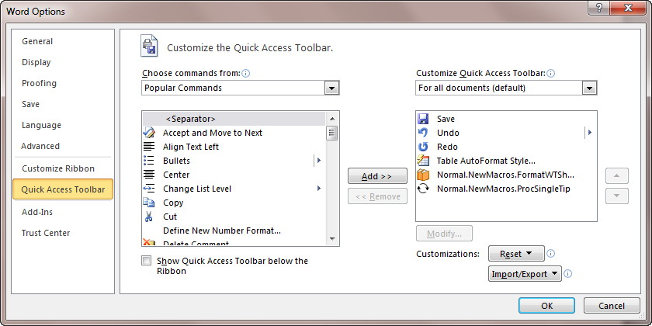
Figure 1. The Quick Access Toolbar area of the Word Options dialog box.
- Using the Choose Commands From drop-down list, choose All Commands.
- 4 In the list of commands, locate and select the Back command.
- Click the Add button. The Back command moves to the right side of the dialog box.
- Click OK.
Your new Back command works just the same as the Back button on a browser, and the same as if you pressed the Alt+Left Arrow shortcut.
Word also provides another helpful command you can add to your toolbar. It was created to specifically allow you to jump back to the TOC. The name of the command is "Go to TOC." The command is very convenient, but only works if you have a single TOC in your document. (If, for instance, you have a TOC at the beginning of each section or chapter in your document, then it won't work as expected.) To add it to a toolbar, follow the same steps you used to add the Back command, with the only difference being that in step 4 you would locate and select the "Go to TOC" command.
Some people prefer to use bookmarks to allow jumping back to the TOC. Select something near the beginning of the TOC (perhaps the TOC's header) and bookmark it. Then you can use either Go To to jump to the bookmark, or you can use a small macro to jump back to it:
Sub BackTOC()
Selection.GoTo What:=wdGoToBookmark, Name:="MyTOC"
End Sub
In this case, the name of the bookmark is MyTOC. This macro could be assigned to a keyboard shortcut or it could end up on a toolbar.
You could also create a hyperlink in your document that that jumped back to the bookmark. This hyperlink could easily be placed at the end of each section of your document, or even in the footer of each page.
WordTips is your source for cost-effective Microsoft Word training. (Microsoft Word is the most popular word processing software in the world.) This tip (12266) applies to Microsoft Word 2007 and 2010. You can find a version of this tip for the older menu interface of Word here: Jumping Back to the TOC.
Related Tips:
- Customized Tables of Contents
- Creating a Table of Contents from Heading Levels
- Adding Column Headings to a Table of Contents
- Page Ranges in a TOC
Do More in Less Time! Are you ready to harness the full power of Word 2013 to create professional documents? In this comprehensive guide you'll learn the skills and techniques for efficiently building the documents you need for your professional and your personal life. Check out Word 2013 In Depth today!

Comments for this tip:
Ken Endacott 10 Apr 2015, 06:31
The macro ReverseLinkHeadings will create reverse TOC links so that clicking on a heading will jump the cursor to the TOC entry for that heading.
What it does is place a bookmark at each TOC entry and changes each heading paragraph into a hyperlink pointing to the appropriate bookmark. The bookmarks are given the same hidden name as the TOC bookmarks but with the suffix "R".
Before changes are made to the headings or before the TOC is regenerated the reverse links should be removed and re-created after the changes. The macro RemoveReverseLinks will remove the bookmarks and change the headings back to text.
Sub ReverseLinkHeadings()
Dim hyp As Hyperlink
Dim toc As TableOfContents
Dim bkmk As String
Dim bkmkR As String
Dim sCode As String
If ActiveDocument.TablesOfContents.Count = 0 Then
MsgBox "There are no Tables of Contents in document"
Exit Sub
End If
Options.CtrlClickHyperlinkToOpen = True
Set toc = ActiveDocument.TablesOfContents(1)
For Each hyp In toc.Range.Hyperlinks
bkmk = hyp.SubAddress
bkmkR = bkmk & "R"
hyp.Range.Select
If Selection.Paragraphs(1).Range.Bookmarks.Count > 0 Then
Selection.Paragraphs(1).Range.Bookmarks(1).Delete
End If
ActiveDocument.Bookmarks.Add Range:=Selection.Range, Name:=bkmkR
If ActiveDocument.Bookmarks.Exists(bkmk) Then
ActiveDocument.Bookmarks(bkmk).Range.Select
If Selection.Hyperlinks.Count = 0 Then
With ActiveDocument.Hyperlinks.Add(Anchor:=Selection.Range, _
Address:="", SubAddress:=bkmkR, TextToDisplay:=Selection.Text)
.Range.Select
Selection.ClearCharacterAllFormatting
End With
Else
Selection.Range.Hyperlinks(1).Range.Select
sCode = Selection.Range.Hyperlinks(1).TextToDisplay
Selection.Fields.Unlink
With ActiveDocument.Hyperlinks.Add(Anchor:=Selection.Range, _
Address:="", SubAddress:=bkmkR, TextToDisplay:=sCode)
.Range.Select
Selection.ClearCharacterAllFormatting
End With
ActiveDocument.Bookmarks.Add Range:=Selection.Range, Name:=bkmk
End If
End If
Next hyp
Options.CtrlClickHyperlinkToOpen = False
End Sub
Sub RemoveReverseLinks()
Dim hyp As Hyperlink
Dim toc As TableOfContents
Dim bkmk As String
Dim aRange As Range
If ActiveDocument.TablesOfContents.Count = 0 Then
MsgBox "There are no Tables of Contents in document"
Exit Sub
End If
Set toc = ActiveDocument.TablesOfContents(1)
For Each hyp In toc.Range.Hyperlinks
bkmk = hyp.SubAddress
If ActiveDocument.Bookmarks.Exists(bkmk) Then
ActiveDocument.Bookmarks(bkmk).Range.Select
Selection.MoveEnd unit:=wdCharacter, Count:=-1
If Selection.Hyperlinks.Count > 0 Then
Selection.Range.Hyperlinks(1).Range.Select
Set aRange = Selection.Range
Selection.Fields.Unlink
ActiveDocument.Bookmarks.Add Range:=aRange, Name:=bkmk
If ActiveDocument.Bookmarks.Exists(bkmk & "R") Then
ActiveDocument.Bookmarks(bkmk & "R").Delete
End If
End If
End If
Next hyp
Options.CtrlClickHyperlinkToOpen = False
End Sub

