Making Pictures Show in Word
Have you ever placed a picture in your Word document, only to have the picture not be visible when you are later working in the document? This seems to be a common occurrence, and there are several reasons for this.
Word uses a "layered" approach to documents. Each document has several different layers. You are probably most familiar with the text layer, in which your text actually resides. There are two other layers, as well. First is the header/footer layer, which contains both the header and footer information that appears on every page in your final document. The other layer is the drawing layer, which contains graphic objects.
In reality, text can appear in all three layers of your document. For instance, headers and footers are composed primarily of text, text obviously appears in the text layer, and text boxes can appear in the graphics layer.
Similarly, graphics can appear on all three layers. People don't normally place graphics on the header/footer layer, but they can. Graphics are much more common on both the text layer and the graphics layer. If you place an inline graphic in your document, it is on the text layer; if you place a floating graphic in your document, it is on the graphics layer.
What does this discussion about layers have to do with whether pictures show up in Word? There are a number of ways to view your document, each accessible from the ribbon tools or by clicking on one of the View buttons in the lower-right corner of your screen. Most people do their writing and editing in Draft or Print Layout views. If you are using Draft view, Word displays only the contents of the text layer of your document. Thus, any pictures residing in the header/footer layer or, more commonly, on the drawing layer are not visible. In order to see the pictures on these other layers, you need to switch to Print Layout view. Of course, some pictures are visible when working on your document in Draft view. Why? Because some pictures—inline pictures—are stored on the text layer, and this is the layer being displayed.
You can switch a drawing from the drawing layer to the text layer (or vice versa) by changing whether it is floating or inline. The easiest way to do this is to right-click on the picture to display a Context menu. The Text Wrapping option (Word 2007) or the Wrap Text option (Word 2010) provide different options, including In Line with Text.
Note that you can switch a drawing to the text layer (make it In Line with Text) only if it is a picture that you placed in your document. If it is a graphic object that you created with the Shapes tool on the Insert tab of the ribbon, you cannot do this; the In Line with Text option is not available. Graphic objects such as these can only reside on the drawing layer. This is why Word switches to Print Layout view whenever you choose to insert drawing objects in your document—it knows that these are only visible in Print Layout view.
Despite the foregoing explanation, there are other settings in Word that can affect the visibility of graphics in a document. If you cannot see a drawing that you believe should be visible, you may want to check these:
- Display the Word Options dialog box. (In Word 2007 click the Office button and then click Word Options. In Word 2010 display the File tab of the ribbon and then click Options.)
- Click Advanced at the left side of the screen.
- Scroll through the advanced options until you see the Show Document Content section. (See Figure 1.)
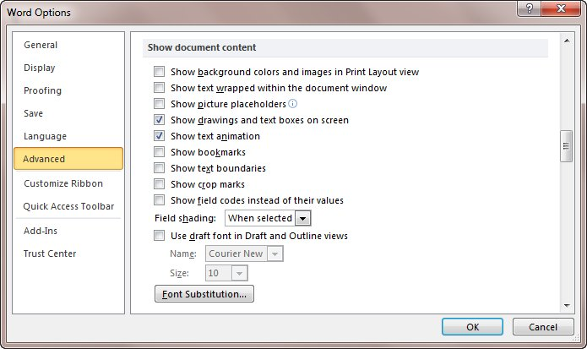
Figure 1. The advanced options of the Word Options dialog box.
- Note the Show Picture Placeholders check box. This check box controls whether Word displays any drawings, regardless of the layer on which they reside. If selected, then Word shows a "placeholder" for the graphic, but not the graphic itself. Set this check box according to your desires.
- Note the Show Drawings and Text Boxes On Screen check box. This check box controls whether drawings are displayed or not when using Print Layout and Web Layout views; set it according to your desires.
- When done, click OK to close the dialog box.
Another thing to remember is that Word treats different types of graphics differently when displaying them. For instance, if you are placing an EPS graphic in your document, and the graphic was not saved with a "preview," then Word won't display it, but will instead display a gray box that shows where the graphic will print. This type of behavior illustrates that graphic filters can affect what you see in a document.

