More tools for staying organized with Microsoft Office Outlook
Learn how to use Microsoft Office Outlook 2007 to help you with your organization, calendar management, email, and contacts.
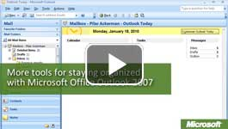

Video: More tools for staying organized
If you already use Microsoft Office Outlook 2007 for common tasks such as managing your email, contacts, and calendar, you can easily start using the other tools and features in Office Outlook 2007 to help stay organized. Watch the video

Simplify more tasks
Outlook is integrated seamlessly with the 2007 Microsoft Office system. For example, you can copy and paste a lesson plan you create in Office Excel 2007 or Office PowerPoint 2007 directly into an email message. Also, many of the features in Outlook 2007 are integrated with other programs in the Microsoft Office 2007. For example, you can create a class newsletter in Office Word 2007 or Office Publisher 2007 and then use mail merge to send it to a list of email recipients.
Here are some tools and features you may not know about.
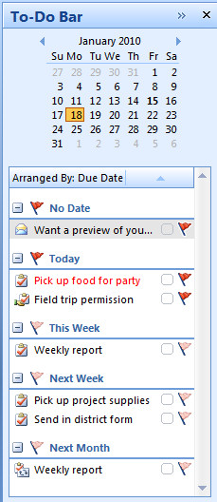
- Tasks. Items in your Outlook To-Do list. Your to-do list of parent requests and school district administrative requirements alone can be daunting. By keeping your to-do list in Office Outlook 2007, you can view and work with the list right next to your email and calendar, and you can tie tasks to your calendar, contacts, and email. For example, you can configure a task to send you recurring reminders, or you can assign tasks to others on your contact list.
- Distribution lists. Subsets of your main contact list. If you have groups of contacts to whom you often send email messages or meeting requests, rather than retype each email address every time, you can group the addresses in a distribution list. For example, you could create a distribution list named Parents. Then, when you send email messages or invitations to all parents, just type Parents in the To line. 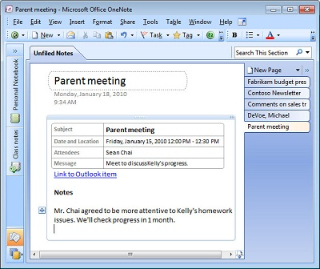
- Notes in Office OneNote 2007. A quick way to take notes and save information after meetings. If Office OneNote 2007 and Office Outlook 2007 are both installed on your computer, you can access OneNote 2007 from within Outlook 2007. For example, after you read an email message, click Send to OneNote to save the message in your notes. In OneNote 2007, you can add notes to the message, along with other items, like files and links. You can also access OneNote 2007 from a Contact or an Appointment and from the Outlook toolbar.

Use Tasks
- On the View menu, click To-Do Bar, and then select Task List. Make sure Normal is selected. The Task List opens in the bottom of the To-Do Bar.
- Right-click the Task List, and click New Task or click New Task Request to assign the task to someone else.
- Type a subject and details. For example, you could create a task to remind you to turn in some forms required by the district.
- Enter other information, such as the date you can start the task and the date the task must be completed. Click Recurrence if the task will be repeated.
- In the To line, enter the email addresses of the contacts to which you want to assign the task.
- Click Send or Save and Close.
- The most current tasks are displayed in the To-Do Bar. To view the complete task list, in the Navigation Pane, click Tasks. Double-click a task in the To-Do List or To-Do Bar to view details.

Create and use a Distribution List
- In the Navigation Pane, click Contacts. Then, on the Actions menu, click New Distribution List.
- Type a name for the list.
- On the Distribution List tab, in the Members group, click Select Members.
- To select multiple names, press Ctrl and click each name.
- Click Members to add the names to the selection list. Then, click OK. The names are added to the distribution list.
- On the Distribution List tab, click Save and Close. 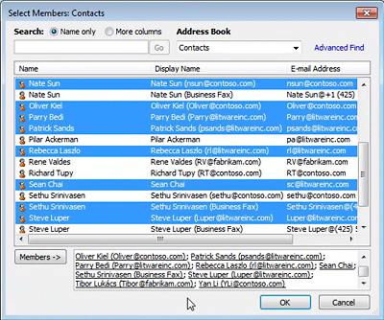
- To use the distribution list to send email, click Mail in the Navigation Pane and open a new Mail Message.
- In the To line, type the name of the distribution list, and press Tab. The name becomes bold and underlined to show that it is in your Outlook Address Book and ready to use.

Take notes in Office OneNote 2007
No matter where you are working in Outlook 2007, you can click the OneNote button in the toolbar or ribbon to copy the item to OneNote 2007 and begin writing notes. For example, after meeting with a parent, you may want to write down some notes while ideas are fresh in your memory.
- Open the Appointment in Calendar.
- On the Appointment tab, in the OneNote group, click Meeting Notes. OneNote opens and then copies the information from the meeting into a new page.
- Under Notes on the page, type your notes. You can also add items, such as files, OneNote tags, or links. You can even record audio.
- The new note is saved in OneNote in Unfiled Notes. You can leave it there or move it to a section in one of your notebooks.
- Later, when you are working in OneNote, you can click Link to Outlook Item to open the Appointment in Outlook.

