How To Use Unified Communication
For questions call: Karen Tohinaka (385)646-4168 or email kttohinaka@graniteschools.org
Part 1: Communicator Set Up Options
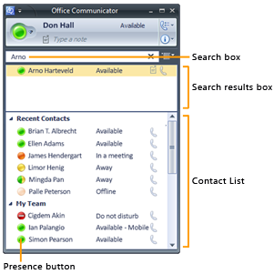

Find a Person or Distribution Group and add to your Contact List
- To find a person, type the person’s name, e-mail address, or phone number in the Search box. To find a distribution group, type the distribution group name or alias in the Search box. As you type, Search results appear in the Search Results box.

Add a person or phone number from Recent Contacts to your Contact List
- Drag the person’s name from the Search Results box to a group in the Contact List or right click on the person’s name and choose Add to Contact List and if you have created a group, you can choose which group to put them in. You cannot add a person to the Recent Contacts group.
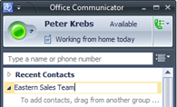

To create a group
- In the Office Communicator main window, right-click an existing group name, and then click Create New Group.
- In the New Group text box, type a name for the group, and then press ENTER.
- You can drag existing contacts from the Contact List into the group or use the Communicator Search feature to find contacts and add them to the group.
- You can also move groups up or down if you use a group often, by right clicking on the group heading and choose move group up or down.

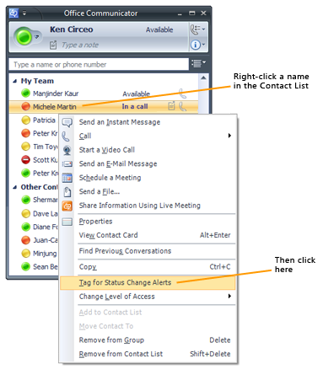

To tag a contact
- In the Contact List, right-click a contact, and then click Tag for Status Change Alerts in case you want to know when they sign in, a box will show on the bottom right of your desktop.

To start an instant messaging session with a group
- Do one of the following:
  - To send an instant message to a distribution group or contact group, right-click a group name, click Send an Instant Message, type a message and then press ENTER.
  - To send an instant message to multiple contacts, hold the CTRL key to select the contacts, right-click the last contact, and then click Send an Instant Message, type a message and then press ENTER.

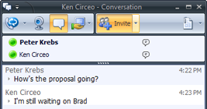

To invite someone to an IM session
- Do one of the following:
  - During an IM session, click Invite in the Conversation window. In the Search box, type a name or select a contact from the Contact List and then click OK or double click on the existing name to add to the session.
  - During an IM session, drag a contact from the Contact List of the Main window into the Participant List of the Conversation window.
Communicator Phone and Video
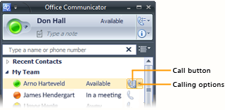

Make a one-click phone call
- In the Contact List, click the contact’s Call button and click on the phone number.

Call an alternate phone number
- In the Contact List, click the arrow to the right of the Call button, and then click the number you want to call.

Enter a phone number to call
- Type the number in the Search box, and then click the Call button next to the number as it appears in the Search Results box. You can enter an internal phone extension, an external number, an alphanumeric number such as 425-555-TAXI, or a contact’s name.

Invite someone to a call
- In the Conversation window, click Invite, and then select a contact, enter a name, or enter a number to call. Or drag and drop into window.

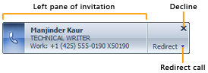

Answer a phone call
- In the phone call invitation alert, click the left pane. The alert appears in the bottom right of your computer screen. If you have a Communicator Phone Edition desk phone or USB audio device attached, lift the handset or press Answer.

Redirect a call
- Click Redirect, and then select an option from the menu. If you choose to redirect a call to an instant message, a call rejection message is sent to the caller and the Conversation window opens so that you can send the caller an instant message.

Redirect unanswered calls to Voice Mail, another number, or a contact
1 | Click the Call Forwarding button, and then click Call-Forwarding Settings.  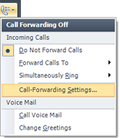
2 | In the Send unanswered calls to the following list, click a number, or click Voice Mail, New Number, or Contact, and then enter the number or select a contact.  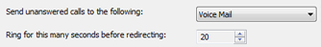
3 | To specify the time period before redirecting the call, in the Ring for this many seconds before redirecting box, use the arrows to increase or decrease the time interval.

Use Call Controls
Call Controls enable you to easily manage your phone calls. For example, you can put a call on hold, transfer a call to another user or phone, or mute a speaker or microphone.
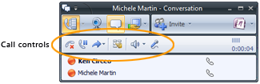
End a call
In the Conversation window, click the End Call button or just hang up the phone.
Put a call on hold
In the Conversation window, click the Hold button.
Transfer an incoming call to another person
Click the call alert invitation to accept the call. In the Conversation window, click the Transfer button, click Another Person, and then select the contact to whom you want to transfer the call.
Transfer an incoming call to another phone
Click the call alert invitation to accept the call. In the Conversation window, click the Transfer button, click Another Person, and then select the phone that you want to transfer to the call to.
Display Dialpad
Click the Dialpad button. This control is often used when prompted for Voice Mail PIN or Access Codes.
Mute speaker or adjust speaker volume
In the Conversation window, click the Mute speaker button to turn off the speaker on your USB phone device. Click the arrow and use the slider to adjust the speaker volume.
Mute microphone
In the Conversation window, click the Mute microphone button to mute the microphone

Forward Calls
Communicator offers several options for automatically forwarding incoming calls. For example, you can forward calls to your Voice Mail, one of your other phone numbers, or another person.

Forward calls to Voice Mail, another phone, or a contact
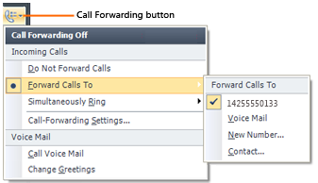
- Click the Call Forwarding button.
- Point to Forward Calls To.
- Select a phone number, Voice Mail, New Number, or Contact.
When calls are forwarded, your phone does not ring. Instead, calls are automatically forwarded to the specified destination.

Ring another number at the same time your number rings
- Click the Call Forwarding button.
- Point to Simultaneously Ring.
- Select a number, or click New Number and enter a number.
The numbers available on the Simultaneously Ring menu are based on the numbers you published on the Phone Options tab. Any new number you enter overwrites an existing number on the Simultaneously Ring menu.

Manage Voice Mail
Your Voice Mail messages appear in your Office Outlook Inbox.

Call Voice Mail
- If you want to call your Voice Mail number to check messages, click the Call Forwarding button and then click Call Voice Mail. Instructions for accessing your Voice Mail, including your Access Number and your Extension and PIN should be provided to you in an e-mail from your administrator.

Change Your Voice Mail Greeting
- If you want to change your Voice Mail greeting, click the Call Forwarding button and then click Change Greetings.

Users to Manage
You can add Microsoft and Qwest users to your contacts as they are
“Federated” with Granite School District. Just type in their email into your contacts.
AOL, Microsoft such as MSN, LIVE, Hot mail, are considered “PIC” users and can be added to your contacts but you will not be able to share your desktop.

Part 2 Conferencing with Communicator

Office Communicator capabilities
- Meet Now Conferences – Users can start Meet Now Communicator conferences when they need to conduct conferences that require IM, audio, video, or desktop-sharing capabilities.
- IM conferences – Users can start IM conferences by inviting additional users to an existing IM conversation or by starting an IM conversation with multiple users.
- Unscheduled audio conference calls – Users can start an ad-hoc conference call by adding additional users to an existing call or by starting a call by selecting multiple contacts in the Communicator Contact List.
- Scheduled audio conference calls – Users can schedule Communicator audio conference calls by using the Outlook Conferencing Add-In. Conference call meeting appointments, when accepted, are added to a user's Outlook Calendar.
- Desktop sharing with audio or IM conferences – With Office Communicator 2007 R2, users have Desktop Sharing capabilities. Users can start desktop sharing during an IM or audio conference.
- Dial-in Conferencing – Dial-in Conferencing can replace your company’s telephone conferencing provider. Dial-in Conferencing enables users to join an audio conference using their computer audio device or using a traditional desk phone or mobile device.
- Users can join from inside or outside the corporate network – With Dial-in Conferencing capabilities, users can dial into an audio conference, regardless of whether they are members of the corporate network.

Escalate Communication Modes
With Office Communicator, you can add communication modes to your conferencing session. For example, you can start an IM conversation with a single contact, add more contacts, and then add audio and video. If you need to share documents or slides, you can share your desktop or escalate to a Live Meeting session.
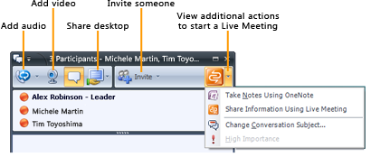

Turn an IM conversation into a conference
- During an IM session, click the Invite button, and then select the contacts that you want to invite to the conference.

Turn an IM conference into a phone or AV conference
- During an IM conference, click Add Audio to add audio to the conference, or click Add Video to add video to the conference.

Share your desktop
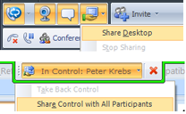
- To allow other participants to view your entire computer desktop during a conversation or IM, click the Sharing button, and then click Share Desktop. Other participants see the message Click to accept invitation to sharing session.
- To share control so that another participant can provide mouse and keyboard input to your desktop, click the down arrow next to In Control: , and then under Share Control, click the name of the participant. To allow any participant to request control, click Share Control with All Participants.

Turn a phone or A/V conference into a Live Meeting
- During a conference call, click the arrow to the right of the Additional Actions button, and then click Share Information Using Live Meeting or Meet Now Using Live Meeting Service. (These options are available only if Live Meeting is installed.)

Start an IM Conference
You can select multiple contacts or a group in your Contact List to start an IM conference. You can also escalate a one-to-one IM session to a group conference by simply inviting other contacts to an IM session.

Start an IM conference with multiple contacts
- In the Contact List, hold the CTRL key, and then select the contacts that you want to invite. Right-click the last contact, and then click Send an Instant Message. Type your message in the Message Entry box, and then press ENTER.

Start an IM conference with a group
- In the Contact List, right-click a group name, and then click Send an Instant Message. Type your message in the Message Entry box, and then press ENTER.
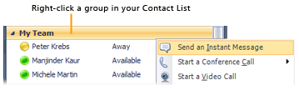

Invite someone to an IM conference
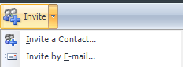
- To invite someone within your organization, in the Conversation window, click the arrow next to the Invite button, click Invite a Contact, and then select the contacts that you want to invite. To invite someone outside your organization by e-mail, click the arrow next to the Invite button, and then click Invite by E-mail. In the e-mail message, type the invitee’s e-mail address and then click Send.

Start an Unscheduled Conference
You can make unscheduled phone conference calls to selected contacts or a group in your Contact List. You can also start a conference call from your mobile phone or from a new phone number that you specify, such as to a hotel room number when you are traveling.

Start a conference call with multiple contacts or a group
- In the Communicator Contact List, do one of the following:
  - To select multiple contacts, hold the CTRL key, and then select the contacts that you want to call. Right-click the last contact, and then point to Start a Conference Call.
  - To select a group, right-click the group, and then point to Start a Conference Call.
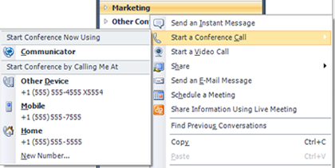
- From the Start a Conference Call menu, do one of the following:
  - To start the call from your default calling device, click Communicator under Start Conference Now Using.
  - Under Start Conference by Calling Me At, click a phone number. Communicator calls the number and joins you to the conference when you answer the call.
  - Click New Number, enter the number, and then click OK.

Join an Unscheduled Conference
- When you receive an unscheduled conference call invitation, the invitation alert appears in the bottom right of your computer screen. In the conference invitation alert, click the left pane. The alert appears in the lower-right corner of your computer screen.
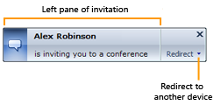

Start an Audio/Video Conference
You can start an audio/video (AV) conference with multiple users or a group that you select in the Contact List.

Start an audio/video conference with multiple contacts
In the Contact List, hold the CTRL key, and then select the contacts that you want to invite. Right-click the last contact, and then click Start a Video Call.

Start an audio/video conference with a group
In the Contact List, right-click a group name, and then click Start a Video Call.
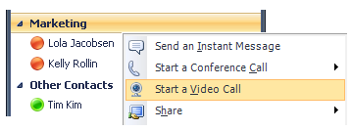

Meet Now from Communicator
With the Meet Now option, you can quickly start a conference with people inside or outside your organization.

Start a conference and invite people inside or outside your organization
- Click the Menu button, and then click Meet Now to open a new conference. To invite others, do one or both of the following:
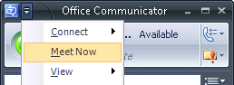
- To invite someone inside your organization, click the Invite button, and then select a contact from the list.
- To invite someone outside your organization by e-mail, in the new conversation window, click the arrow next to the Invite button, and then click Invite by E-mail. An e-mail message opens in Microsoft Outlook. (If you do not have Outlook, you can copy the invitation text to the e-mail program of your choice.) Send the e-mail to the invitee, who can join the conversation by using either Communicator or Communicator Web Access.

