Positioning the Cursor in a New Document
If you are creating standard templates for your company, you may want to go one step further and make sure the cursor (insertion point) is positioned at a particular location whenever a new document is created that is based on the template. This can come in handy, as it ensures that the insertion point is at the proper place to begin typing in the new document.
This is a relatively easy process to do. Follow these steps:
- Open the template on which the new documents are to be based.
- Position the insertion point at the position in the document where you want it positioned when you create a new document based on the template.
- Press Shift+Ctrl+F5. Word displays the Bookmark dialog box. (See Figure 1.)
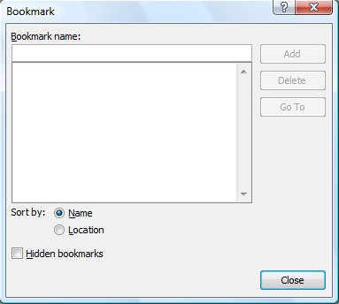
Figure 1. The Bookmark dialog box.
- In the Bookmark Name field, enter a unique name for your bookmark, such as StartHere. (Notice there are no spaces in this bookmark name.)
- Click on the Add button. Word adds the new bookmark and closes the Bookmark dialog box.
- Press Ctrl+Home to go to the start of your template. (This step is not absolutely necessary, but it makes it easier to understand some of the later steps.)
- Display the Developer tab of the ribbon.
- Click the Record Macro tool. Word displays the Record Macro dialog box.
- Use the Macro Name of AutoNew. This must be a single word, capitalized as shown. (This is a special macro name that denotes a macro to be run whenever a new document is created.)
- Use the Store Macro In pull-down list to select the name of the template on which you are working.
- Click on OK. Your macro is now being recorded.
- Press F5. Word displays the Go To tab of the Find and Replace dialog box. (See Figure 2.)
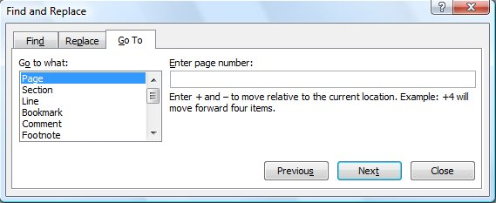
Figure 2. The Go To tab of the Find and Replace dialog box.
- In the Go To What list, select Bookmark.
- Using the drop-down list labeled Enter Bookmark Name, select the name of the bookmark you defined in step 4.
- Click on Go To. You should now jump to the location of where you set the bookmark.
- Click on Close to get rid of the Find and Replace dialog box.
- Click on the Stop Recording tool to stop your macro.
- Save and close your template. (When you save your template, make sure you save it as a macro-enabled template—one that uses the DOTM filename extension.)
That's it! The next time you create a document based on the template, the AutoRun macro will automatically execute, and you will jump to the designated spot.

