Printing Comments
If you've defined a group of comments in your document, you may want to print them at some time. Word provides a variety of ways that your comments can appear when printed. Follow these steps if you are using Word 2007:
- Press Ctrl+P. Word displays the Print dialog box. (See Figure 1.)
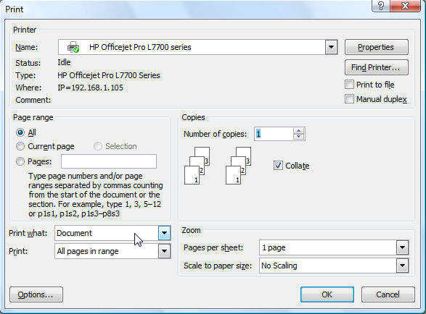
Figure 1. The Print dialog box.
- Using the Print What drop-down list, choose either List of Markup or Document Showing Markup. (The first prints just the comments and other document markup, the second prints the document together with any comments and other document markup.)
- Click OK.
If you are using Word 2010 or Word 2013 follow these steps instead:
- Press Ctrl+P. Word displays the Print portion of the File tab.
- Click the drop-down list immediately under the Settings label. The choices in this drop-down list allow you to specify exactly what it is you want to print. (See Figure 2.)
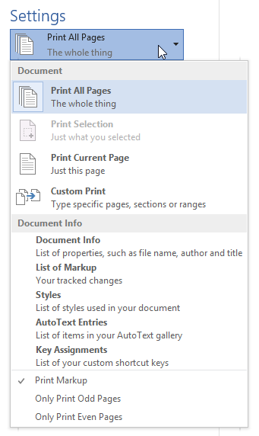
Figure 2. The print settings options.
- If you want to print just your comments (along with any other markup made to your document), choose List of Markup in the Document Properties section (Word 2010) or Document Info section (Word 2013).
- If you want to print your document together with your comments (along with any other markup made to your document), make sure Print Markup is selected and that you choose one of the options in the Document section.
- Click the Print button.

