Putting Your Index after Your Endnotes
When you start adding different elements to your documents, you may wonder how to order those elements. For instance, Word allows you to easily add elements such as tables of contents, other special tables, footnotes, endnotes, and indexes. If your document contains both endnotes and an index, you may wonder how you can place your index after your endnotes.
The reason for this confusion typically crops up because Word allows you to specify where your endnotes are placed—at the end of a section or the end of the document. You obviously don't want the endnotes at the end of your document if you want your index to appear after the endnotes. So, the solution is to add a "next page" section break after the end of your document's body and just before the index. Your document should now contain two sections—one for the body of the document and one for the index. So, in the main body of the document format your endnotes so that they appear at the end of the section. You can do that by following these steps:
- Position the insertion point within the section that contains your endnotes (the main body of your document).
- Make sure the References tab of the ribbon is displayed.
- Click the small icon at the bottom-right of the Footnotes group. Word displays the Footnote and Endnote dialog box.
- Click the Endnotes radio button. (See Figure 1.)
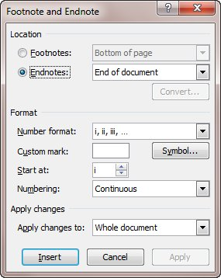
Figure 1. The Footnote and Endnote dialog box.
- Using the drop-down list to the right of the Endnotes radio button, choose End of Section.
- Click the Apply button.
- Click Cancel to close the Footnote and Endnote dialog box.
Word then automatically places the endnotes before your index, just as you want.
Of course, if you are already using multiple sections in your document, then this simple approach won't work as you expect. You can still place your endnotes where you want, however:
- Place the "next page" section break just before your index, as described earlier in this tip.
- Make sure the References tab of the ribbon is displayed.
- Click the small icon at the bottom-right of the Footnotes group. Word displays the Footnote and Endnote dialog box.
- Click the Endnotes radio button.
- Using the drop-down list to the right of the Endnotes radio button, choose End of Section.
- Using the Numbering drop down list, choose Continuous.
- Using the Apply Changes To drop-down list, choose Whole Document.
- Click the Apply button.
- Click Cancel to close the Footnote and Endnote dialog box.
- Display the Page Layout tab of the ribbon.
- Click the small icon at the bottom-right of the Page Setup group. Word displays the Page Setup dialog box.
- Make sure the Layout tab is selected. (See Figure 2.)
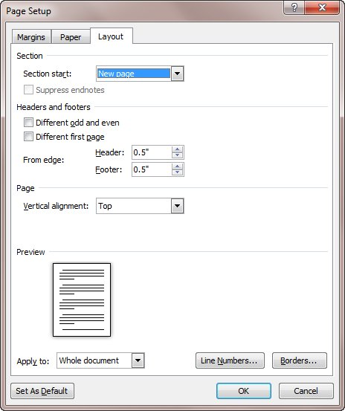
Figure 2. The Layout tab of the Page Setup dialog box.
- Choose the Suppress Endnotes check box. (The check box is only accessible if two conditions are met: There are actually endnotes in your document and you've set the endnotes to appear at the end of the section instead of the end of the document.)
- Using the Apply To drop-down list, choose Whole Document.
- Click on OK.
- Position the insertion point in the section just before the section that contains the index. (In other words, put it in the section after which you want the endnotes to appear.)
- Display the Page Layout tab of the ribbon.
- Click the small icon at the bottom-right of the Page Setup group. Word displays the Page Setup dialog box.
- Make sure the Layout tab is selected.
- Clear the Suppress Endnotes checkbox.
- Using the Apply To drop-down list, choose This Section.
- Click on OK.
Now Word suppresses the endnotes for all the sections except the one you specified (in steps 16 and 21), so all your endnotes appear there—just before your index.

