Replace text using wildcards
Sometimes, you need something a bit more powerful than basic Find and Replace. Wildcards help you search for variations of words, multiple words at once, or similar groups of words.

Search by using wildcards to find specific letters
Use wildcards to search for text. For example, you can use the asterisk (*) wildcard to search for a string of characters (for example, "s*d" finds "sad" and "started").

Use wildcards to find and replace text
- On the Home tab, in the Editing group, click the arrow next to Find, and then click Advanced Find.
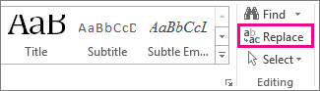
- Select the Use wildcards check box
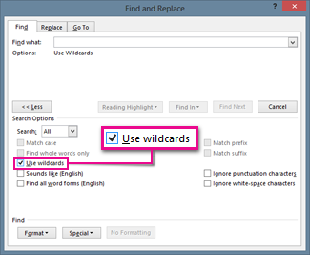
If you don't see the Use wildcards check box, click More.
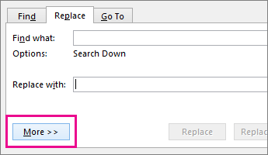
- Do one of the following:
  - To choose a wildcard character from a list, click Special, click a wildcard character, and then type any additional text in the Find what box. For more information, see the table Wildcards for items you want to find and replace.
  - Type a wildcard character directly in the Find what box. For more information, see the table Wildcards for items you want to find and replace.
- If you want to replace the item, click the Replace tab, and then type what you want to use as a replacement in the Replace with box.
- Click Find Next, Find All, Replace, or Replace All.
Note To cancel a search in progress, press ESC.

Expressions in wildcard searches
Use parentheses ( ) to create groups of wildcard characters and text in the Find What box, then use \n in the Replace With box to use the results of each expression.
You can use the \n wildcard to search for an expression and then replace it with the rearranged expression. For example, type (Ashton) (Chris) in the Find what box and \2 \1 in the Replace with box. Word will find Ashton Chris and replace it with Chris Ashton.

Wildcards for items you want to find and replace
Notes
- When the Use wildcards check box is selected, Word finds only the exact text that you specify. Notice that the Match case and Find whole words only check boxes are unavailable (dimmed) to indicate that these options are automatically turned on. You can't turn off these options.
- To search for a character that's defined as a wildcard, type a backslash (\) before the character. For example, type \? to find a question mark or \\ to find a backslash character (this is often called an “escape character”).
- You can use parentheses to group the wildcard characters and text and to indicate the order of evaluation. For example, type <(pre)*(ed)> to find "presorted" and "prevented".
To find | Type | Example
Any single character, including space and punctuation characters | ? | s?t finds sat, set, and s t.
One of these characters | [ ] | w[io]n finds win and won.
Any single character in this range | [-] | [r-t]ight finds right, sight, and tight. Ranges must be in ascending order.
The beginning of a word | < | <(inter) finds interesting and intercept, but not splintered.
The end of a word | > | (in)> finds in and within, but not interesting.
Expression | () | Word remembers the results of a search combination to use in a replace operation.
Any single character except the characters in the range inside the brackets | [!x-z] | t[!a-m]ck finds tock and tuck, but not tack or tick.
Exactly n occurrences of the previous character or expression | {n} | fe{2}d finds feed but not fed.
At least n occurrences of the previous character or expression | {n,} | fe{1,}d finds fed and feed.
From n to m occurrences of the previous character or expression | {n,m} | 10{1,3} finds 10, 100, and 1000.
One or more occurrences of the previous character or expression | @ | lo@t finds lot and loot.
Any string of characters, including space and punctuation characters | * | s*d finds sad, started, and significantly altered.

Use codes to find letters, formatting, fields, or special characters
Use the following codes to find letters, formatting, fields, or special characters. Note that different codes are available when the Use wildcards option is turned on or off.

Codes that work in the Find what box or Replace with box
To find | Type
Paragraph mark ( ) | ^p (doesn't work in the Find what box when the Use wildcards option is turned on), or ^13
Tab character ( ) | ^t or ^9
ASCII character | ^nnn, where nnn is the character code.
ANSI character | ^0nnn, where 0 is zero and nnn is the character code
Em dash ( — ) | ^+
En dash ( – ) | ^=
Caret character | ^^
Manual line break ( ) | ^l or ^11
Column break | ^n or ^14
Page or section break | ^12 (when replacing, inserts a page break)
Manual page break | ^m (also finds or replaces section breaks when the Use wildcards option is turned on)
Nonbreaking space ( ) | ^s
Nonbreaking hyphen ( ) | ^~
Optional hyphen ( ) | ^-

