Replacing Multiple Spaces with Tabs
You may receive a document from someone that uses multiple spaces to separate items on a line. This is typically done when a person wants to format tabular material, and separates columns using spaces. You can find this quite a bit in information downloaded from the Web.
If you are starting with a source document in this condition, you may be wondering how you can replace all the consecutive spaces with a single tab character. It is possible to go through multiple search-and-replace operations to achieve the desired goal, but there is a quicker way. You can replace any number of consecutive spaces with a single tab character by following these steps:
- Press Ctrl+H. Word displays the Replace tab of the Find and Replace dialog box.
- Click on the More button if it is available. (See Figure 1.)
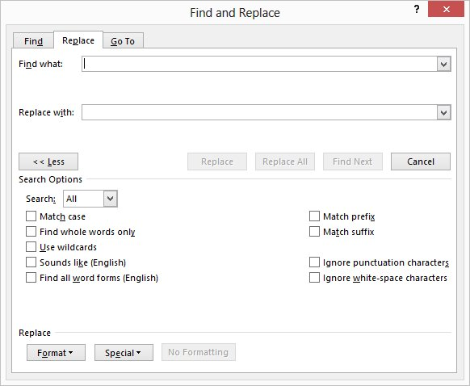
Figure 1. The Replace tab of the Find and Replace dialog box.
- In the Find What box, enter a single space followed by the characters {2,}. (Type only the left brace, the number 2, the comma, and the right brace.)
- In the Replace With box, type ^t.
- Make sure the Use Wildcards check box is selected.
- Click on Replace All.
If the document has the Nonbreaking Space which is represented by a superscript "o" character instead of the traditional space marking in your document, you will need to use the Nonbreaking Space in the Step 3 instead of the Single Space before typing {2,}.
To use the Non-Braking Space, you can either use the keyboard shortcut keys and hold down the Ctrl plus Shift keys and then press the Space Bar. Or in the Find and Replace dialog box click on Special button (as seen in Figure 1 in original Tip). Then choose the Nonbreaking Space selection (second from the bottom in the list). This puts the following characters "^s".

