Retaining Explicit Formatting after Applying Styles
I often get documents that have a hodgepodge of styles and I need to format them in addition to editing them. When I click in a paragraph and apply a paragraph style, Word is not supposed to wipe out any explicit character formatting in the paragraph, such as italics. Sometimes it does and sometimes it doesn't; this probably has something to do with the way the documents were put together and over which I have no control.
This led me to search for a way to preserve any italics within the paragraphs. I came up with the following general steps:
- If you are using Word 2007, press Ctrl+F. Word displays the Find tab of the Find and Replace dialog box. If you are using a later version of Word, press Ctrl+H to display the Find and Replace dialog box, then click the Find tab.
- Click the More button, if it is available. (See Figure 1.)
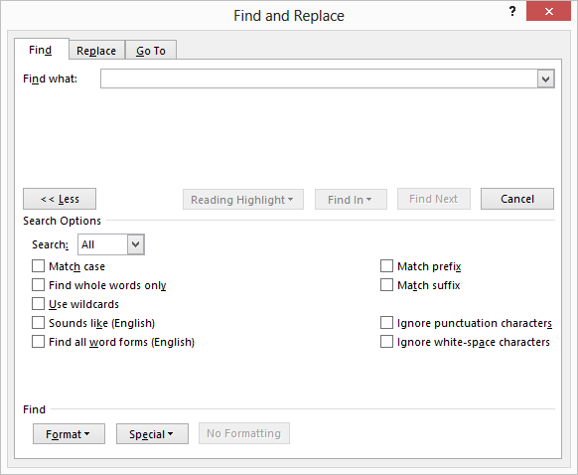
Figure 1. The Find tab of the Find and Replace dialog box.
- Make sure the Find What box is empty.
- Click the Format button and choose Font. Word displays the Font tab of the Find Font dialog box.
- Make sure Italic is selected in the Font Style list and click OK. The words "Font: Italic" appear under the Find What box.
- Click the Find In drop-down list and choose Main Document. Word selects all instances of italics text in the document.
- Click Close. The Find and Replace dialog box is closed and everything that is italics should be selected in the document.
- Click the Highlight tool. This highlights all the selected text. All the italics text is now highlighted, in yellow.
- Apply paragraph styles as desired, throughout the document. Some of the italics may disappear, some may not, but the highlighting should remain unchanged.
- If you are using Word 2007, press Ctrl+F. Word again displays the Find tab of the Find and Replace dialog box. If you are using a later version of Word, press Ctrl+H to display the Find and Replace dialog box, then click the Find tab.
- Click the More button, if it is available.
- Make sure the Find What box is empty.
- Click the No Formatting button, if it is available.
- Click the Format button and choose Highlight. The word "Highlight" appears under the Find What box.
- Click the Find In drop-down list and choose Main Document. Word selects all instances of italics text in the document.
- Click Close. Everything that is highlighted should be selected in the document.
At this point you can click the Italics tool in the Font group of the Home tab of the ribbon until all the selected text is shown in italics. You can then click the Highlight tool, again, which removes all the highlighting.

