Rotate a Graphic Using the Keyboard
Don knows how to rotate a graphic using the mouse. He wonders, though, if there is a way to rotate a graphic using nothing but the keyboard.
The short answer is "not really." The reason for this is because before you can rotate a graphic you need to select it, and selecting can only be done (as far as I can tell) by using the mouse. If you've just clicked on the graphic to select it, your mouse pointer is already very close to the rotation handle, so you might as well use it to do the rotation.
That being said, after you select the graphic (again, using the mouse) you could use the Alt key, in conjunction with the left and right arrow keys, to rotate the graphic in 15-degree increments in the direction consistent with the arrow key used.
If you want a bit finer control over the rotation, you can follow this convoluted set of steps:
- Select the graphic.
- Press and release the Alt key. Word displays a set of shortcut indicators next to the ribbon tools.
- Press JP to select the Format tab of the ribbon.
- Press AY to activate the Rotate tool.
- Press R or L to rotate the graphic 90 degrees right or left.
- If you prefer, press M to display the options that allow you to specify a rotation angle directly.
You could also set up a keyboard shortcut to directly display the options that appear when you press M. Follow these steps:
- Display the Word Options dialog box. (In Word 2007 click the Office button and then click Word Options. In Word 2010 and Word 2013 display the File tab of the ribbon and then click Options.)
- At the left side of the dialog box click Customize (Word 2007) or Customize Ribbon (later versions of Word). (See Figure 1.)
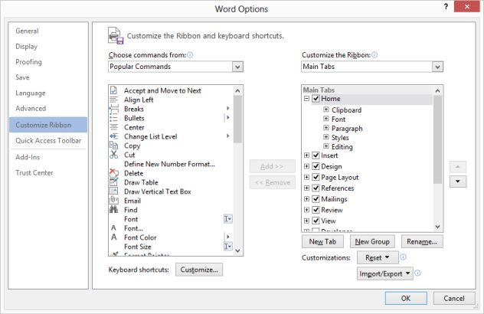
Figure 1. The customize options of the Word Options dialog box.
- Click the Customize button, near the bottom of the dialog box. Word displays the Customize Keyboard dialog box. (See Figure 2.)
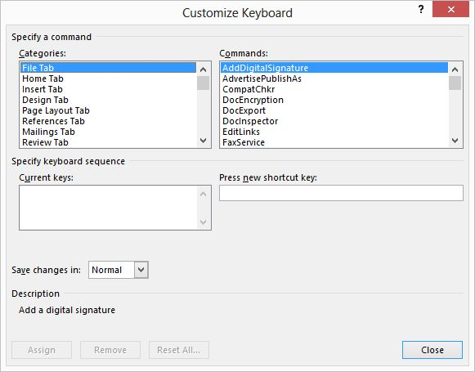
Figure 2. The Customize Keyboard dialog box.
- In the list of Categories, choose All Commands.
- In the list of Commands, choose MoreRotationOption.
- Place the insertion point in the Press New Shortcut Key box.
- Press the shortcut key you want to use, such as Alt+R.
- Click Assign.
- Close the dialog boxes.
Now, after selecting a graphic, you can jump right to the rotation options by pressing the shortcut key you defined in step 7.
Of course, you could also create a set of macros to do the rotations for you and then assign those macros to a set of keyboard shortcuts. The following consists of four macros, three of which can be used to easily rotate a graphic. The RotateCW1 and RotateCW5 macros rotate a graphic clockwise either 1 or 5 degrees. The RotateCCW5 macro rotates a graphic 5 degrees counterclockwise. All three graphics rely on the RotateShape macro to do the majority of the work.
Sub RotateCW1()
RotateShape (1)
End Sub
Sub RotateCW5()
RotateShape (5)
End Sub
Sub RotateCCW5()
RotateShape (-5)
End Sub
Sub RotateShape(Degrees As Single)
With Selection
If .ShapeRange.Count = 0 And .Range.ShapeRange.Count = 0 Then
MsgBox "No shape selected"
Exit Sub
End If
If .ShapeRange.Count > 0 Then
.ShapeRange.IncrementRotation Degrees
Else
.Range.ShapeRange(1).IncrementRotation Degrees
End If
End With
End Sub
Again, assign the RotateCW1, RotateCW5, and RotateCCW5 macros to shortcut keys and you can then directly rotate a selected graphic as desired.

Comments for this tip:
Ken Endacott 16 Mar 2015, 07:48
Here is a complete macro to rotate shapes including inline shapes.
Sub RotateShape(Degrees As Single)
Dim scountR As Long
Dim scountI As Long
Dim scountS As Long
With Selection
scountR = 0
scountI = 0
scountS = 0
On Error Resume Next
scountS = scountS + .ShapeRange.Count
scountI = scountI + .InlineShapes.Count
scountR = scountR + .Range.ShapeRange.Count
On Error GoTo 0
If Val(Application.Version) < 14 And scountS > 0 Then
If .ShapeRange(1).Type = msoTextBox Then
MsgBox "Cannot rotate textbox in Word 2007"
Exit Sub
End If
End If
If scountR + scountS + scountI = 0 Then
MsgBox "No shape has been selected"
Exit Sub
End If
If scountS > 0 Then .ShapeRange.IncrementRotation Degrees
If scountR > 0 Then .Range.ShapeRange.IncrementRotation Degrees
If scountI > 0 Then
On Error Resume Next
.InlineShapes(1).ConvertToShape
.ShapeRange.IncrementRotation Degrees
.ShapeRange(1).WrapFormat.Type = wdWrapInline
On Error GoTo 0
End If
End With
End Sub

