Selecting and Moving by Sentences
If you prefer to not use macros, you can also move through sentences by customizing Word to take advantage of some "hidden" commands. Follow these steps:
- Display the Word Options dialog box. (In Word 2007 click the Office button and then click Word Options. In Word 2010 click the File tab of the ribbon and then click Options.)
- At the left side of the dialog box click Customize (Word 2007) or Customize Ribbon (Word 2010). (See Figure 1.)
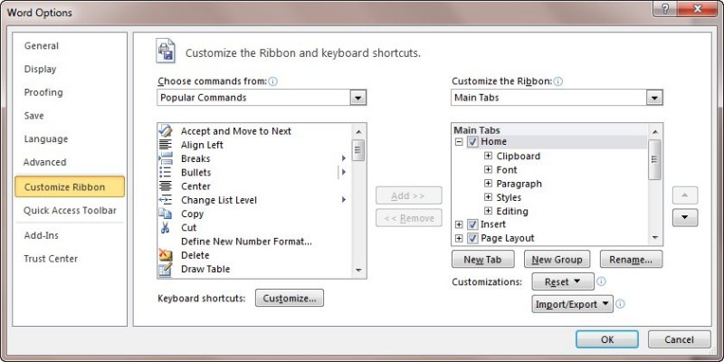
Figure 1. The customize ribbon area of the Word Options dialog box.
- At the bottom of the dialog box click Customize, next to the Keyboard Shortcuts label. Word displays the Customize Keyboard dialog box. (See Figure 2.)
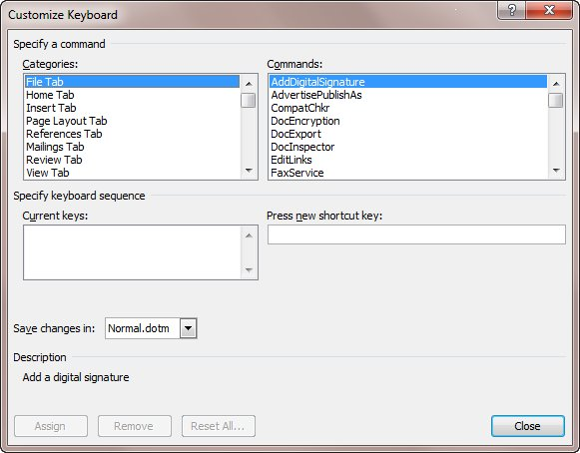
Figure 2. The Customize Keyboard dialog box.
- In the Categories list, choose All Commands.
- In the Commands list, choose SentLeft.
- Click in the Press New Shortcut Key box.
- Press Alt+Left Arrow.
- Click on Assign.
- Click Close, then close the Word Options dialog box as well.
After performing this series of steps, you can step backwards through your document, one sentence at a time, simply by pressing Alt+Left Arrow. You can also repeat the steps and assign the following
Action |  | Commands List |  | Shortcut Key
Step right by sentences |  | SentRight |  | Alt+Right Arrow
Step left and select |  | SentLeftExtend |  | Shift+Alt+Left Arrow
Step right and select |  | SentRightExtend |  | Shift+Alt+Right Arrow
Most Word users will find these keyboard commands a welcome addition to the normal editing keys. You should know, however, that some of these suggested shortcut keys are already in use by Word. For instance, the Shift+Alt+Left Arrow combination is used to promote a heading level in an outline. However, if you can live without that use of the keys, then go for it. (Personally, I think this reassigned use makes much more sense.) If you would rather use a different key combination, you can do so by using any one you would like in step 7 above.

