Selecting Noncontiguous Ranges with the Keyboard
Most people know that you can select a noncontiguous range of cells by using the mouse. All you need to do is click the first cell in the range and then hold down the Ctrl key as you click other cells in the range. (This is often referred to as creating a selection set of cells.)
Some folks don't like using the mouse that much. If you are in that camp, you may wonder if there is a way to select a noncontiguous range simply by using the keyboard. Fortunately there is, but very few folks know about it. Provided that you know the addresses of the cells you want in the range, follow these steps:
- Press F5 or Ctrl+G. Excel displays the Go To dialog box. (See Figure 1.)
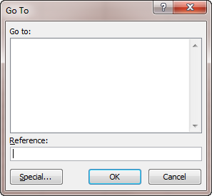
Figure 1. The Go To dialog box.
- In the Reference box at the bottom of the dialog box, type the address of the first cell or range you want selected.
- Type a comma, followed by an additional range.
- Repeat step 3 for each additional cell or range you want in the selection set.
- Click OK (or press Enter). Excel selects all the cells and ranges you entered in the Reference box.
As an example, if you wanted your noncontiguous range to include cells A7, B2, F14 through G22, and T18, you would enter the following into the Reference box:
A7,B2,F14:G22,T18
Clicking OK then selects all these cells. In addition, the last cell that you entered is the "active cell" in the selected range.

