Setting Your Default Document Directory
Normally, Word starts looking for documents in the directory in which you started the program. If you want to change the default directory path, you can do so in the following manner:
- Display the Word Options dialog box. (In Word 2007 click the Office button and then click Word Options. In Word 2010 and Word 2013 display the File tab of the ribbon and then click Options.)
- Click Advanced at the left side of the dialog box.
- Scroll all the way to the bottom of the available options and locate the File Locations button. Click on it. Word displays the File Locations dialog box. (See Figure 1.)
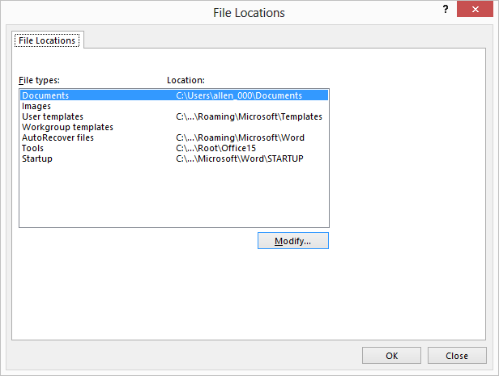
Figure 1. The File Locations dialog box.
- Make sure the Documents option is selected from the list of file types. (This is the first choice in the list, and is typically selected by default.)
- Click on the Modify button. Word displays the Modify Location dialog box.
- Use the controls in the dialog box to locate the directory you want used as the default document directory.
- Click on OK. The directory you selected in step 6 should now appear in the Options dialog box.
- Click on OK to close the File Locations dialog box.
- Click on OK to close the Word Options dialog box.
Note that this setting affects only the beginning directory used by Word to look for documents, before you do any opening and saving of documents. There are other actions you can take in Word that will affect the default directory proposed by the program. For instance, if you open a Word document that is in a folder different than the default one you set in step 6, and then you use Save As to save the document under a different name, then proposed directory will not match the one set in step 6. Instead, Word proposes to save the file in the same directory that the original document was stored in.

