Specifying a Language for Text
by Allen Wyatt (last updated February 6, 2015)
Word includes many tools to make your writing better. A few of the tools make use of specialized dictionaries; for instance the grammar and spelling checker. You can pick a language to be used on either a single paragraph, or on all instances of a particular paragraph style. To change which language is used for a particular paragraph, follow these steps:
- Select the paragraphs or defined style for which you want to change the language.
- Display the Review tab of the ribbon.
- If you are using Word 2007 click the Set Language tool in the Proofing group. If you are using Word 2010 or Word 2013 click the Language tool in the Language group and then click Set Proofing Language. Word displays the Language dialog box. (See Figure 1.)
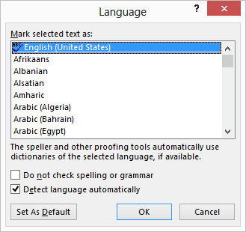
Figure 1. The Language dialog box.
- Select a language from those in the language list.
- Click on OK.
If you want to specify that all paragraphs formatted with a particular style use a certain language, then follow these steps:
- Display the Home tab of the ribbon.
- Click the small icon at the bottom-right of the Styles group. Word displays the Styles pane at the right side of the desktop.
- In the list of styles, make sure the style you want to change is visible.
- Hover the mouse pointer over the name of the style you want to change. Notice that a downward-pointing arrow appears at the right side of the style name.
- Click on the downward-pointing arrow and choose the Modify option from the resulting menu. Word displays the Modify Style dialog box.
- Click on the Format button, then choose the Language option. Word displays the Language dialog box.
- Select a language from those in the language list.
- Click on OK, then on OK again.
- Close the Styles pane.
Any paragraphs currently using the style you specified in step 4 (or any paragraphs to which you apply that style in the future) will be formatted for the language you picked in step 7.

