Tell a story with Windows Live Movie Maker
Learn how to make movies and tell stories with images and text using the free Windows Live Movie Maker.
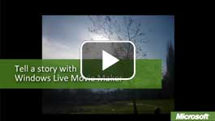

Video: Tell a story with Windows Live Movie Maker
Children often don't recognize how multiple stories or events fit together. To develop perspective and learn storytelling, they can create movies with images and text from their day's activities and then share them on the web. Watch the video

Sequence events
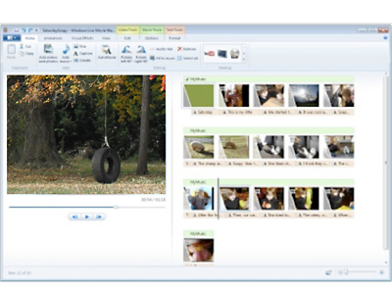
Use Windows Live Movie Maker to help students tell the story of their day.

Windows Live Movie Maker (Windows Movie Maker in Microsoft Windows XP) is a movie and slide show creator. With Movie Maker, students can experiment with the best ways to arrange their photos to tell the story of their day. In doing so, they learn which elements hold the viewer's attention and make for good storytelling. Students can add titles, effects, movement, transitions, and even a music track to create a finished product. After saving the final movie, students can upload their work to a site such as YouTube or their Windows Live Space and share it with you, their families, and others in their class.

Make a movie about a day in your life
- Pick an interesting day, and bring your camera with you wherever you go. In the example, the student focuses on the experiences of his little sister. Plan on taking more pictures than you will need for your movie. That way, you'll have plenty of pictures to choose from. For example, if you want to make a one-minute movie and show each picture for about five seconds, you will need at least 12 pictures for the movie. Shoot at least 30 pictures to make sure you have enough to choose from.
- Upload the pictures to your computer.
- Open Windows Live Movie Maker and, on the Home tab, click Add videos and photos.
- Select the pictures that you want in your movie. Hold down the Ctrl key to select multiple files. Then, click Open. The pictures are added to the storyboard area on the right.
- To play the movie, click the Play button on the media player. The cursor moves across the rows of pictures as the movie plays. By default, each picture shows for five seconds.
- To edit your movie, do any of the following:
  - To move a picture, drag it to a new position.
  - To delete a picture, select it and press Delete.
  - To add a picture, click Add videos and photos on the Home tab.
  - To change how long a picture displays, select the picture, and then, on the Video Tools Edit tab, change the duration.
- After you have chosen your images, placed them in the sequence you like, and adjusted the timing, you can do more:
  - To add titles, click where you want to add a title slide in the storyboard. On the Home tab, click Title and type the title. Click the Text Tools Format tab to change the formatting or add a background color.
  - To add captions, click the picture. On the Home tab, click Caption and type the caption. Click the Text Tools Format tab to change the formatting. Drag the text container borders to change the shape of the container or to move the caption. 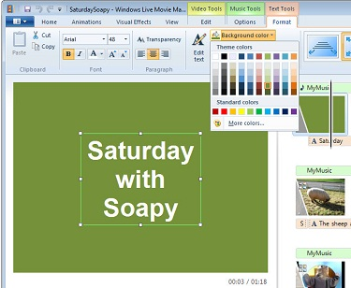
  - To add movement, click the picture. On the Animations tab, in the Pan and Zoom group, click the More button, and select an option in the gallery.
  - To add transitions, click the picture. On the Animations tab, in the Transitions group, click the More button, and select an option in the gallery.
  - To play music with the pictures, on the Home tab, click Add music, and then click Add music or Add music at the current point. Browse for the music file that you want to use, and then click Open.
- When you finish the movie, on the Home tab, in the Sharing group, click the More button. Then choose how you want to save the final movie file.

