Turning Off Printing of Document Properties
John is using Word 2010, and the program prints out a page of document properties with every document he prints. He wonders how he can change this so that the document properties don't print unless he wants them to.
Believe it or not, this is actually a setting that you can control in Word. This setting is provided because some people like to have the document properties printed each time they print their document. If you don't want them printed, then follow these steps:
- Display the Word Options dialog box. (In Word 2007 click the Office button and then click Word Options. In Word 2010 display the File tab of the ribbon and then click Options.)
- At the left side of the dialog box click Display. (See Figure 1.)
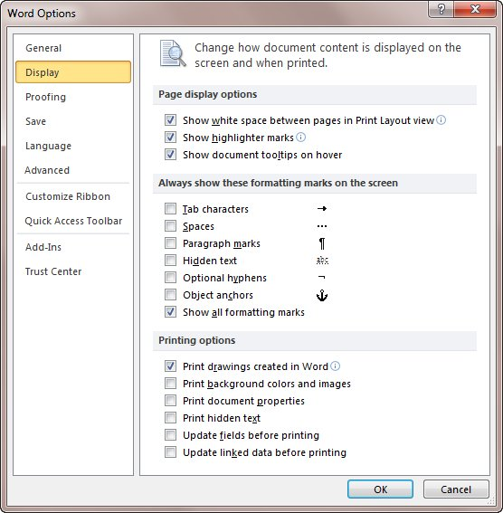
Figure 1. The display options of the Word Options dialog box.
- In the Printing Options section (bottom of the dialog box), make sure the Print Document Properties check box is cleared.
- Click OK.

