Use special calculations in Microsoft Office Excel 2007
Learn how to use special calculations, counting, and data with Microsoft Office Excel 2007.
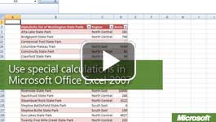

Video: Use special calculations in Microsoft Office Excel 2007
To quickly and easily count all of the numbers in a group or range of cells (or just the ones that match a certain condition), use specific functions in Office Excel 2007. Watch the video

SUMIF and COUNTIF calculations
SUMIF adds numbers in a range that match certain criteria, and COUNTIF counts the number of cells that match certain criteria.
The functions look like this:
=SUMIF(range, criteria, sum range)
=COUNTIF(range, criteria)
Range represents the group of cells that you want to evaluate, criteria represents the comparison that you want to make, and sum range (in SUMIF) represents the range you want to add if the criteria are true.
In the following example, the formula analyzes a list of international airports, the continent each is in, and the amount of air traffic they receive annually.

Create a special calculation
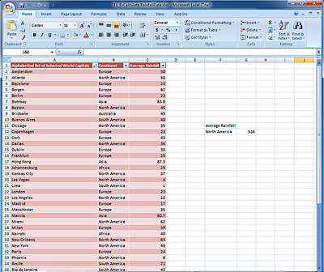
Use special calculations to help analyze data in spreadsheets.
- Enter your data in an Office Excel 2007 worksheet. The figure shows data formatted as a table to make it easier to work with.
- Select a cell outside of your data range or table, enter the function you want to use, and fill in the required arguments, such as range and name. Keep in mind that values, like text and dates, need to be enclosed in quotation marks.

