Working with Form Fields
The fields available for use in forms are accessible through the Developer tab of the ribbon. If you don't see the Developer tab (it isn't visible on your system), you need to instruct Word to display it.
If you display the Developer tab and take a look at the Controls group, you'll notice that there are a bunch of controls available. None of these controls are form fields. Instead, you need to click the Legacy Tools icon, which displays a whole group of controls that originate with older versions of Word. The Legacy Forms group (visible after you click the Legacy Tools icon) includes three types of form fields you can insert in a document: text, check box, and pull-down. Each of these form fields allows the user of the form to select or enter information of the type that you deem appropriate.
As an example, let's say you are creating an order form and you need a field where a user can enter the name of the person making the order. Further, you want to allow only up to 25 characters to be entered in the field. To accomplish this, follow these steps:
- Position the insertion point where you want the field to appear.
- Display the Developer tab of the ribbon.
- In the Controls group click Legacy Tools and then click the Text Form Field tool. A field indicator appears in the document.
- Right-click the form field just entered and choose Properties from the resulting Context menu. The Text Form Field Options dialog box appears. (See Figure 1.)
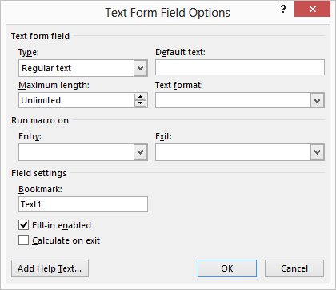
Figure 1. The Text Form Field Options dialog box.
- Make sure the Type pull-down list is set to Regular Text. (This is the type of information you want to allow in the field.)
- Change the Maximum Length option to 25.
- Click on OK.
You can repeat these steps for all the fields in your form. The only difference would be the type of field entered (which should be appropriate to the type of information you want entered) and the options you set for each field.
The trickiest option you can set is the Maximum Length option, which only appears when you are working with text fields. By default, this option is set to Unlimited, which means the user can enter any amount of information desired. If the information being entered exceeds the right margin of your document, the field height increases and the text entry continues on the next line. If you don't want this effect in your form, then the only way around it is to set some maximum length for the field. For instance, if you don't want your field to wrap to the next line, then you need to set a maximum length guaranteed to fit on a single line. Calculating such a length can be difficult, particularly if you are using a proportional font. For this reason, some people like to set the font of their fields to a monospace font, such as Courier; it makes calculating field lengths easier.
One way around the potential "overrun" problem is to create a table to contain your form fields. The advantage to this is that you can define the width and height of every cell in your table, which limits the vertical movement of text fields if they should be too long. The disadvantage is that some information is not readily displayed in tabular format, and if the entered text is too long, it is not all displayed on the screen or printout. (If the text overruns the size of a static table cell, the additional information is suppressed.
As you set the options for your various fields, notice that you can also define macros that can be executed when the field is entered (first selected) and when it is exited. These allow you to process the information provided in the field.
When a form is being used, the information entered into a field is assigned to a bookmark name. This name is specified in the Options dialog box for each field. Through the use of other bookmark-related fields, you can thus reference field contents elsewhere in your document.

